RasterPlus Windows Edition
User's Guide
And
Device Notes

Version 5.0
© 2004 Graphx, Inc
Contents
GETTING STARTED 1
What do I have in Front of Me? 1
What do I need to run RasterPlus? 1
What is RasterPlus Windows Edition? 1
Who Can Use RasterPlus? 2
The Power of PostScript 2
Standard Technical Support 3
Extended Technical Support 3
INSTALLATION 5
Upgrading from a Previous Version 5
Installing RasterPlus Version 5 6
Uninstalling RasterPlus Windows Edition V5.0 8
Register RasterPlus 9
What next? 10
QUICK START 12
Before You Begin 12
How To Print 12
Queue Printing 12
Application Printing 14
Before You Begin 14
Configure RasterPlus for Application Printing 14
Printing from an Application 15
Printing from PowerPoint 15
POWERPOINT SPECIFIC NOTES 17
Print Preview When Application Printing 17
Previewing Jobs in the Hold Pane 19
RasterPlus In Detail 20
The RasterPlus Application 20
Tools 22
Index Printing 23
Previewing Jobs 24
Selecting Jobs in a Pane 27
Queue and Job Properties 27
Setting Default Queue Properties 27
Standard Device Properties 30
Advanced Device Properties 32
Resources Properties 32
Color Transform Properties 35
Sizing Properties 37
Creating Custom Transforms 38
Editing a Custom Transform 38
NETWORK PRINTING 40
WINDOWS 95/98/ME AS A HOST PRINT SERVER 40
WINDOWS NT/2000/XP/2003 AS A HOST PRINT SERVER 42
HOT FOLDER PRINTING 44
Digital Package Printing 46
PACKAGEPLUSTM - CREATE CUSTOM PACKAGES 50
USING PACKAGEPLUS CUSTOM PACKAGES 58
TrueGraphx Color Management System 62
ICC COLOR TRANSFORMS WITH TRUEGRAPHX 62
CREATING NEW ICC PROFILES 63
RENDERING INTENT STYLES 63
Connecting Your Device 65
SCSI 65
GPIB 71
BitmapPlus 75
Minilabs 79
Agfa 80
Fuji Frontier 84
US Standard Interface 85
PIC Pro Interface 86
C4/C5 Interface 87
Generic Minilab 90
Gretag NETPRINTER and MILECA 94
Kodak DLS Minilab 97
Konica 101
Noritsu 105
MP-1600 AND QSS-2701 105
QSS-2801, QSS-2802, QSS-2901,QSS-3001, QSS-3011, QSS-3101, QSS-31PRO, QSS-32 Series, QSS-33xx Series, dDP Series 108
Film Recorders 112
AGFA/Matrix Color Film Rrecorders 113
CCG Color Film Recorders 115
LaserGraphics 116
MGI 118
Polaroid Digital Palette 120
Mirus 125
Montage Graphics 127
Samurai CFR 128
Sony UP-D8800/UP-D70A/POLAROID PLD8800 129
UTI/Celco 130
Printers 131
Fuji Pictrography 2000, 3000, 3500, 4000/4000II AND Pictrostat 400 132
Fuji PrintPix – NC-600D and NC-1000 134
Kodak XL 7700 AND XLT 7720 136
Kodak 8650/8670/8660 137
Mitsubishi 9000D and 9500D Series 138
Sienna/Gretag Fotoprint 139
Printer Cloaking with RasterPlus 140

GETTING STARTED
This is the Installation Guide for RasterPlus Windows Edition. This guide is designed to lead you through the install procedure and point out items that you should be aware of during the installation.

What do I have in Front of Me?
You should have one box with:
- A Quick Start Guide
- A RasterPlus Windows Edition CD

What do I need to run RasterPlus?
- Microsoft Windows 95/98/NT4/2000/ME/XP/2003
- Intel-based computer with a Pentium class CPU (150MHz per device)
- 32 megabytes of memory per device for Windows 95/98/ME®
- 64 megabytes of memory per device for Windows NT4/2000/XP/2003
- CD-ROM drive
- Approximately 100 megabytes of free disk space
- A RasterPlus-supported printer

You may also need to install other manufacturer-supplied drivers so that RasterPlus can communicate with your printer. Before attempting to print to your device, be sure to review the setup and configuration notes for your printer in the RasterPlus on-line help file.

What is RasterPlus Windows Edition?
RasterPlus Windows Edition is a high-performance print system for the Microsoft Windows operating system. RasterPlus streamlines complex printing tasks and delivers dramatically improved print quality, speed and color fidelity. Whether you have a color film recorder, photorealistic printer or minilab, RasterPlus gives you the right tools to make the winning print.

With RasterPlus you can:
- Turn supported printers into PostScript printers.
- Get blazing-fast print times and improved print quality.
- Leverage the investment in your PC by performing image-processing operations on your PC, not in the slower CPU of your printer.
- Send PostScript, JPEG, TIFF, PDF, and other image files directly to your printer without first loading the files into an application.
- Print directly to high-end devices, like color film recorders and photorealistic printers, which are not supported with standard Windows drivers.
- Preview jobs before printing them; saving time and costly media.
- Provide robust print server support to connected Windows and Macintosh computers.
- Print file editing resize, crop and move your print files before you print them.

Whether you are a novice or an imaging professional, you will be amazed at what RasterPlus will do for your output.

Who Can Use RasterPlus?
Photo Labs can print and package images on high-end continuous-tone color printers. Service bureaus can use the powerful queuing and reporting features of RasterPlus to print PostScript and bitmap files sent by their customers. Corporate imaging centers can use the extensive networking capabilities of RasterPlus devices to offer centralized print services to their users.

The Power of PostScript
At the heart of RasterPlus is a PostScript 3 engine that quickly renders your files to deliver the very best output with smooth gradations between colors, razor sharp fonts and a wide range of special graphics effects. Modern Windows applications, like PowerPoint and CorelDraw, have features, which only work on PostScript printers. And RasterPlus is the most cost-effective way to make these applications see your printer as a true PostScript printer.

With the power of RasterPlus PostScript you can:
- Print documents with embedded EPS files - a non PostScript printer will only give you a low-resolution black and white preview of the embedded EPS file on your output.
- Print documents with rotated images or bitmaps - Windows does not directly support the rotation of bitmaps; the bitmap will print without rotation or will not print at all on a non-PostScript printer.
- Get the highest quality blends and fountain fills - some applications, like CorelDraw, send lower quality blends to non-PostScript printers.

Standard Technical Support
Graphx has gained a worldwide reputation for developing innovative products while providing excellent customer support. We realize that our customer service is an important part of your overall satisfaction with our products. That is why we give all registered customers:

- Free phone support for current version customers for 90 days after licensing
- Comprehensive web site (www.photogize.com) with the latest solutions on technical issues.
- Free minor version updates downloadable from our web site.
- A full 30-day money back guarantee from date of purchase.
- Searchable Web Knowledgebase

Extended Technical Support
Graphx also provides extended support with the SupportPlus program. To order SupportPlus and immediately receive SupportPlus benefits visit our website (www.photogize.com) or call our sales department.

About Graphx
With over 15 years of experience in digital photographic printing, Graphx designed RasterPlus to address the specific needs of photo labs, service bureaus, and corporate imaging centers. The results speak for themselves in the easiest to use, most robust, and fastest printing solution available today for digital color printers.

INSTALLATION

Upgrading from a Previous Version
RasterPlus Windows Edition 5.x or later can co-exist with RasterPlus 95 1.x - 2.x. However, we recommend removing all older versions of RasterPlus from your system before installing a new copy (not a patch) of RasterPlus.

To remove RasterPlus from your system:
- From the Windows Control Panel, double-click Add/Remove Programs.
- Highlight RasterPlus.
- Click Add/Remove...
- Follow the removal instructions, which follow.
- Remove the RasterPlus folder from Program Files\Graphx.
- The security key or dongle from earlier versions is no longer required.

Installing RasterPlus Version 5
Note: If you are running Windows NT/2000/XP/2003, you must be logged in as an Administrator to install RasterPlus, or have Administrator privileges as part of a Users Group.

- Connect the printer to the computer. Turn the printer on first, and then turn on the computer.
- Insert the RasterPlus CD into the CD drive. The RasterPlus setup program should run. If it doesn't, select Start...Run from the Windows taskbar and type in e:\setup.exe where "e" is the drive letter of your CD. Then click OK, the setup program should run.
- During the installation you will be asked to enter your serial number. You can find this number on the manual and the product packaging.
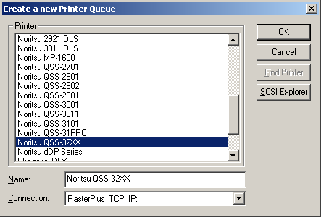
- The RasterPlus setup program will guide you through the installation of the RasterPlus program. During the setup you will be asked to create a new Printer Queue for the RasterPlus-supported device to which you wish to print. RasterPlus will create a new Queue for the device and install the appropriate print driver in your Windows Control Panel...Printers.
- You'll also need to specify the Connection for your printer (e.g. LPT1:, SCSI3:, etc.) at this time. RasterPlus can find and automatically set the connection for many printers. To find and automatically set the Connection for your printer, click the Find Printer button. If the Find Printer button is unavailable, RasterPlus cannot find the selected printer and you will need to manually specify the connection.

Uninstalling RasterPlus Windows Edition V5.0
If you want to completely remove RasterPlus from your system:
- Select Start... Settings...Control Panel from the Windows taskbar.
- Double click Add/Remove Programs in the Windows Control Panel.
- Highlight RasterPlus and click Add/Remove...

RasterPlus program files, devices, registry entries and the RasterPlus icon in the Start Menu will be deleted. The uninstaller may say that some files could not be uninstalled or deleted. This could mean that you have copied files to the RasterPlus installation directory after installing RasterPlus. Usually, RasterPlus is installed in the Program Files\Graphx directory on your hard disk. If needed, you can manually remove the Graphx\RasterPlus directory (and the files located in the directory) AFTER uninstalling RasterPlus.

Register RasterPlus
Now that you have installed RasterPlus you must register your software with Graphx. RasterPlus functions in Demo Mode for 14 days starting upon installation. Product registration makes your copy 100% functional and gives you access to technical support and information about new product releases.

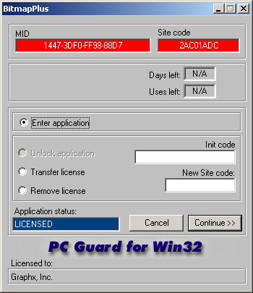
To register go to the RasterPlus menu bar and Select Tools...License Manager, which will open the screen below.

Write down, or Copy and Paste, the "MID" and "Site Code" displayed in the red windows. Next you can choose between two registration methods.
- To register on the web go to Help...Web Registration, which will open your web browser and take you to the registration page at Graphx.com. After submitting the required information you will receive a message from Graphx, within one business day, with an Init Code to be entered in the field in the License Code window to the right.

- To register by email send a message to register@graphx.com with "Windows" in the subject line. The following information must be included RasterPlus User's Guide in the body of your message to complete the registration. You can copy and past the following text into your message to use as a template:

  - MID Code (from License Code Window)
  - Site Code (from License Code Window)
  - Product Name
  - Version #
  - Serial #
  - Your First and Last Name
  - Company Name
  - Department/Title
  - Street, City, State
  - Postal/Zip Code
  - Country
  - Email Address
  - Phone Number
  - Date of Purchase
  - RasterPlus Dealer Name

You will receive a message from Graphx, within one business day, with an Init Code to be entered in the field in the License Code window above.

What next?
After RasterPlus is installed on your computer, you are ready to configure the software and print. The Quick Start chapter will get you on your way to printing with RasterPlus.

RasterPlus also provides robust networking capabilities. Because the RasterPlus print driver is based on the standard Microsoft Windows PostScript driver, it can be shared like any other Windows print driver. If you are running RasterPlus on Windows NT server, Windows and Macintosh users can all install and use your shared print driver. RasterPlus can also be set to poll a "hot" folder; it will grab files from this folder and print them. For more information on networking, please see the Network Printing Chapter.

QUICK START

Before You Begin
Please make sure that you:
- Review device-specific information in this manual or in the RasterPlus on-line help file.
- Install any special drivers or utilities required by your device.

How To Print
RasterPlus provides two distinctly different printing services, depending on your needs:
- If you have print-ready files, like PostScript, TIFF, or JPEG, RasterPlus can send them directly to your device. See the Queue Printing section.
- If you want to print from within any Windows application, RasterPlus devices are installed as Windows PostScript printers. See the Application Printing section.

Queue Printing
To verify that RasterPlus was installed correctly and that your device is working properly, we recommend that you print one or more of our sample files to your printer.

Configure RasterPlus for Queue Printing
- Launch RasterPlus and make sure that the appropriate device Queue is active.
- Select Edit...Default Queue Properties and click on the General tab.
- Verify the device settings.
- Click OK.

Printing from the Queue
Right click in the Print Pane and select Add files from the context menu. Highlight the ‘HAPPY KIDS.JPG’ file and click OK.
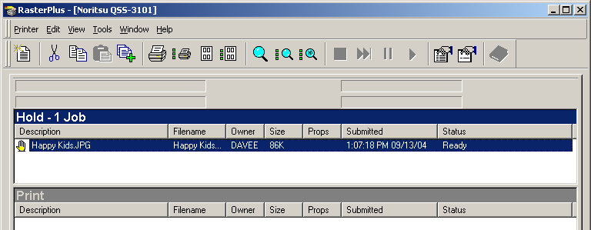
The ‘HAPPY KIDS.JPG’ file will now be printed to the device. There are additional high-resolution photographic sample files on the CD in the \Photo Samples folder.

To print all Jobs in the Hold or Archive Pane, highlight the Pane and select Printer...Print All Jobs.

To print some Jobs in the Hold or Archive Pane, select the Jobs and drag them to the Print Pane or select Printer...Print Selected Jobs. When the Job is complete, it will be moved to the Archive Pane. To reprint, simply drag the Job back to the print Pane.

Application Printing

Before You Begin
RasterPlus installs an application print driver whenever you create a new Queue. You are prompted to create a new Queue during setup and that application print driver should now be available under Windows Start...Settings...Printers. If you cannot find the application print driver, or if it was mistakenly deleted, you can re-create it by:

- Launch RasterPlus (select Start...Programs...Graphx...RasterPlus from the Windows taskbar).
- Select the printer Queue for which you wish to create an application print driver.
- Select Printer...Reinstall Application Print Driver.

If your device does not show up in RasterPlus, you can create it by selecting Printer...New from the RasterPlus Main Menu. A new Queue and application print driver will be created.

You can now close RasterPlus, as it will automatically launch when you File Print from your application.

Configure RasterPlus for Application Printing
Whenever RasterPlus installs a new printer Queue, an application printer driver is created for the printer in Windows Start...Settings...Printers. To configure this printer driver and select appropriate default properties:

- Right-click on the printer under Windows Start...Settings...Printers (In RasterPlus select Printer...Configure Application Print Driver.)
- Verify the printer port, which connects the PC to the printer.
- Select the appropriate default paper, resolution, and options for the printer. Click OK.

To set these default Properties in Windows NT, select Printers, right click on your printer and select Document Defaults...Advanced. In Windows 2000/XP/2003 versions, Printer Preferences... Advanced.

Also, please make sure that you:
- Review device-specific information in this manual or in the RasterPlus PDF help file.
- Install any special drivers or utilities required by your device.

Printing from an Application
To print from an application using a RasterPlus-installed application print driver, simply select the print driver from your application and print.

- Launch any Windows application you want to print from.
- Select File...Page Setup and verify that the paper size matches your printer.
- Select File...Print and select the appropriate RasterPlus printer and click OK.

RasterPlus will automatically be launched and a spool file will be placed in the Print Pane and printed. When the Job is complete, it will be moved to the Archive Pane. To reprint, simply drag the Job back to the print Pane.

Printing from PowerPoint
Many Windows applications work like PowerPoint; if you don't have PowerPoint you can use these instructions as a general guideline for printing from any Windows application. The following instructions assume you are printing to a color film recorder.

- Launch PowerPoint from the Start menu and load or create a presentation.
- Select File...Page Setup in PowerPoint and select 35mm in the Slides Sized for combo box.
- Click OK.
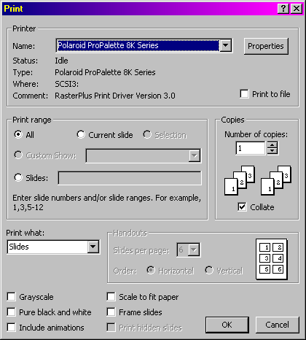
- Select File...Print and select the printer you just installed.

- Click Properties and select the Paper tab. Select PowerPoint 35mm page size, set orientation to landscape, and click OK.
- Click OK.
Your document will now be printed to your device. Note that under normal circumstances you don't need to launch RasterPlus first to print from your application. RasterPlus will automatically launch to image the file.

POWERPOINT SPECIFIC NOTES
PowerPoint page setup can be set to:
- 35mm (7.33x11.00)
- PowerPoint 35mm (7.5x11.25)
- OnScreen Show, the PowerPoint Default (7.5x10)

RasterPlus Windows Editions includes paper sizes for all three. When printing, the paper size must match the page setup size or incorrect results will occur.

Note: When printing from an application and multiple copies are needed, the recommended method is to select one (1) copy, then select the required number of copies in the Job Properties of the file.

The file will only have to rip once and will speed up the printing process.

Print Preview When Application Printing
To preview (soft-proof) Jobs before they print set the Print to Hold Pane option in your application print driver to Yes. You can do this from the RasterPlus Spooler by selecting Printer...Configure Application Print Driver from the Main Menu. In Windows 95/98/ME, click Device Options and select the Print to Hold Pane setting. Set this to Yes and click OK. In Windows NT4/2000, click on Advanced and scroll down to the Printer Specific setting. Set Print to Hold Pane to Yes and click OK. You can also make this setting from most applications.

Now when you print, the Jobs will go into the Hold Pane. From here, just select the Job and select Printer...Preview Selected Jobs from the Main Menu.

Previewing Jobs in the Hold Pane
To preview all files in the Hold Pane, select Printer...Preview All Jobs. To preview some files in the Hold Pane, select the Jobs and select Printer...Preview Selected Jobs. Selecting Preview Selected Jobs - High Definition opens a window with a preview with scroll bars and Zoom In (+) and Out (-) tools for viewing details of the image. This is especially useful for catching flaws in a file, thereby presenting the opportunity to save ink and media on a print job.

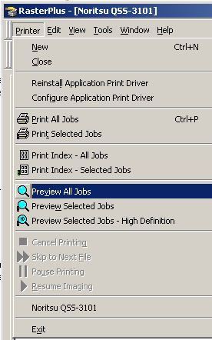
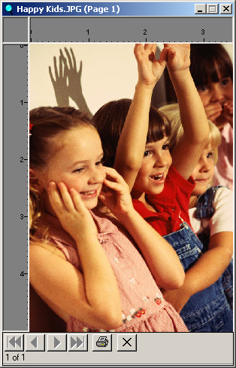

RasterPlus In Detail

The RasterPlus Application
To launch RasterPlus, select Start...Programs...Graphx...RasterPlus from the Windows taskbar. After you launch RasterPlus you will see this screen:

The RasterPlus application is made up of several components.

Main Menu
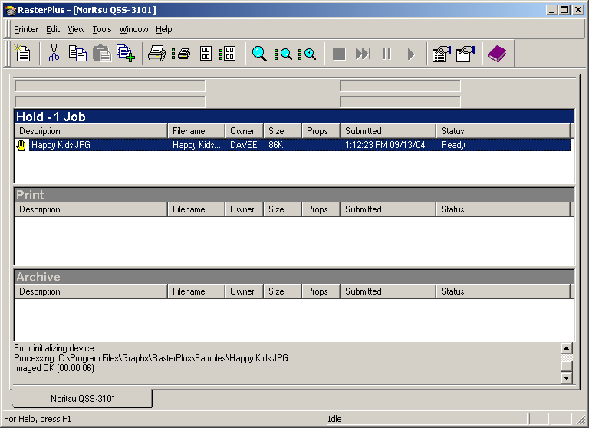
Many of the menu items can be selected using the toolbar or a shortcut key (listed on the right side of the menu item). The Main Menu in RasterPlus is dockable and can be made to float or dock by double clicking on an open area in the menu.

Toolbar
The toolbar offers shortcuts for often-used menu items. The toolbar is also dockable and can be made to float or dock by double clicking on an open area in the menu. If you hover your mouse over a toolbar item, a tooltip will tell you what the icon means.

New Device Queue

Cut or delete from Queue

Add Jobs.

Print All Jobs

Print Selected Jobs

Preview All Jobs

Preview Selected Jobs

High Definition Preview

Index All Jobs (see below)
Index Selected Jobs (see below)
Cancel Printing or Previewing
Skip to Next Job

Pause Printing or Previewing
Resume Printing or Previewing

Queue Properties

Job Properties

View RasterPlus Log file

Tools

From the menu bar select Tools...Options to open:

Under the General tab are options for setting Preview Size (small is fastest), Pause after each image is displayed, Automatically make next preview screen active, Show rulers, and size of Toolbar buttons.
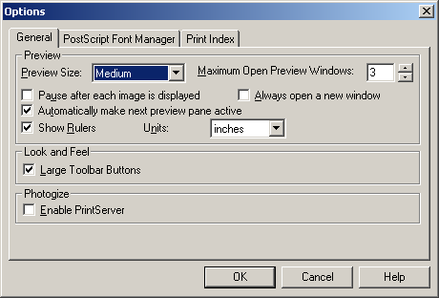
RasterPlus 5.0 is Photogize ready - the Graphx system for receiving graphic files over the internet and printing them on digital minilabs or professional digital photo printers. See your Photogize consultant for details.

The Postscript Font Manager allows you to add fonts to the standard set of Fonts that comes with RasterPlus.

Index Printing
The Print Index tab sets up options for making index prints of the files in the Hold Queue. The index print itself is printed by clicking the button for Index All Jobs or Index Selected Jobs on the menu bar.

- Use single page for all images - on or off
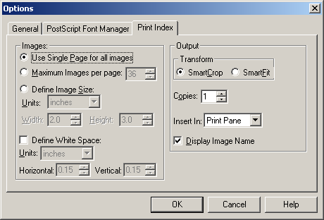
- Maximum Images per page
- Define Image Size

- Define White Space between index prints.
- Horizontal and Vertical are defined independently.
- Transform - SmartCrop or SmartFit (independent of the Image Layout selected)
- Specify the number of copies of the index print.
- Insert In: Define where the Index Print will be placed, the Hold Pane or the Print Pane.
- Display Image Name - on or off.

Print preview does not display the index page setup.

Previewing Jobs
The image Preview Functions helps save imaging time and expense. Launched by a command from either the pull-down menu bar or the menu bar button a preview window shows the selected image or group of images. Height and width scales show the final output dimensions as configured in Queue or Job Properties. Navigational buttons below the previewed image allow you to move through the selected group. And, the print button prints the current image on the screen. To change the size of the Print Preview Window go to Tools...Options...General...Preview Size and choose Small, Medium, or Large. The Large preview takes the most time to generate an image on the screen.

To generate a High Definition Preview select one or more files and either Select Printer...Preview Selected Jobs – High Definition or click the High Definition button. Now, use the (+) or (-) "magnifiers" to zoom in or out and the slider bars to navigate up/down or left/right in the preview.

Queue Status Bar
The Queue Status Bar is below the toolbar. It shows real-time printing and previewing information. It is also dockable.

Printer Queues
There is one print Queue for each installed RasterPlus printer. Tabs at the bottom of the Queue represent these Queues. Each Queue is divided into three areas: The Hold Pane, Print Pane, and Archive Pane.

Hold Pane
The place to organize, preview, and pre-flight files destined to be printed. To print Jobs in the Hold Pane, simply select the files you want to print and drag them into the Print Pane or select Printer...Print Selected Jobs.

Print Pane
The place where Jobs are printed. Note that the Print Pane is always "hot"; when you add a Job to it. Jobs will immediately start printing.

Archive Pane
The place where previously printed Jobs are sent to after printing. You can also drag Jobs from the Hold Pane to the Archive Pane for storage.

Jobs
A Job is a print ready spool file, or hot-folder-captured file, which sits on a single line in a pane. Each Job contains the following information:

Description
A text description, which is generated by the printing application or by RasterPlus for each Job. You can edit the Description by clicking Job Properties\General.

Filename
The actual name of the disk file of the Job.

Owner
The name of the computer, which sent the Job to the pane.
Size
The size of the file in bytes.

Props
If you have specified custom Device, Sizing, or Color Job Properties, a single character (D for Device, S for Sizing, and C for Color) will be displayed here.

Submitted
The date and time that the Job was added to the Pane

Status
The status of the print Job

Note: If any text element of the Job is obscured, the missing part will be obscured by three dots. If you hover your mouse over it, the entire text element will show as a tooltip.

Adding, deleting, moving, and copying Jobs in the Queue
You can add print-ready files to the queue in a number of ways:

- Click on the Add Files toolbar icon and choose one or more files from the dialog
- Select Edit...Add Files and choose one or more files from the dialog
- Hit the Ins key and choose one or more files from the dialog
- Drag and drop files from other Panes or Queues or from the Windows Explorer

To delete files from the queue, select the files and hit the Del key, click the scissor icon from the toolbar, or select Edit...Cut. Note that this operation only deletes the reference to the file from the Queue; not the image file itself. Also note that you cannot delete a file that is currently being previewed or printed.

To move files within a Pane or from one Pane or Queue to another, select the files you wish to move and select Edit...Cut from the menu (or click on the Cut icon in the Toolbar). Click on the spot in the Queue where you wish to insert the files and select Edit…Paste from the menu (or click on the Paste icon in the toolbar). You can also simply click on the file(s) and drag them to the desired position.

If you want to copy files within a Pane or from one Pane or Queue to another, select the files you wish to copy, and select Edit...Copy from the menu (or click on the Copy icon in the Toolbar). Click on the spot in the Queue where you wish to insert the files and select Edit...Paste from the menu (or click on the Paste icon in the toolbar). You can also simply click on the file(s), hold down the Ctrl key and drag them to the desired position.

Selecting Jobs in a Pane
Some operations, like Printing, Previewing and Deleting, allow you to work on single or multiple files in a Pane. To select a file, just click on the file with the mouse. To select multiple files, hold the Ctrl key and click on the files you wish to select. To select a range of files, click on a file, hold the Shift key down, and click on another file; all files inclusively between these two files will be selected.

Queue and Job Properties
RasterPlus provides two methods of defining how Jobs will print. Queue Properties provide the default values for Jobs added to the Queue. Individual Jobs can be modified with unique properties of their own. Whenever a Job comes from an application, the printer properties of the application print dialog provide the default Job properties.

Setting Default Queue Properties
To set properties for a Queue, select Edit...Default Queue Properties from the Main menu or click on the Default Queue Properties icon in the Toolbar.

There are six tabs in the dialog:

General
Lets you specify general settings for the Queue device (like connection and media size) as well as set data management options and anti-aliasing.
Advanced Device
Lets you make settings which are specific to your device.
Sizing
Set general sizing and cropping options which will apply to all Jobs in the Queue.
Color Transforms
Apply ICC profile or Rendering Intent correction to all Jobs in the Queue. (Not all devices support ICC profiles.)
Color Adjustments
Adjust the hue or contrast of all Jobs in the Queue.
Resources
Set scratch folders, memory usage, archive file disposition, and hot folder particulars.

Setting Job Properties
To set properties for a Particular Job in a Pane, select one or more Jobs and select Edit...Job Properties from the Main menu, click on the Job Properties icon in the Toolbar, or double-click on a Job.

There are five tabs in the dialog:
General
Displays information about the Job and lets you specify general settings for the Queue device like connection and media size as well as set data management options and anti-aliasing.
Advanced Device
Lets you make settings which are specific to your device.
Sizing
Set general sizing and cropping options
Color Transforms
Apply ICC profile or Rendering Intent correction to the Job(s). (Not all RasterPlus devices support ICC profiles.)
WINDOWS NT AND WINDOWS 95 DO NOT SUPPORT ICC PROFILE PROCESSING.
Color Adjustments
Adjust the hue or contrast of the Job(s)

Standard Device Properties
All RasterPlus-supported devices are configured using the General Property page in Edit...Default Queue Properties or Edit...Job Properties. If a particular field is not applicable to the selected device, the field is grayed.

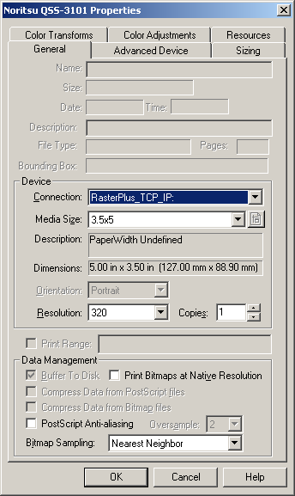
Device

Connection
Specify the port to which the device is connected (e.g.: LPT1:, SCSI4:, etc.)
Media Size
The actual size and/or description of the media (e.g.: 35mm, Letter)
Resolution
The resolution the printer should use to print the job (e.g.: 372 dpi,
4096)
Copies
The number of copies to print of each Job

Data Management

Buffer to Disk
Buffer the printer data to disk prior to sending. If a "banding" rip is required, and buffering to disk is appropriate for your device, this field will be accessible. You should check this box if your device is data-delivery sensitive so that the data is delivered more smoothly (most film recorders produce best results when you check this box).

Compress Data from PostScript File
Compress the image data prior to sending to the device. If this field is accessible, you should generally check it unless you are printing files with VERY large bitmaps (>25MB) which don't compress especially well.
Note: If you don't check this field, and Buffer to Disk is set, the image data will be buffered WITHOUT compression to disk, resulting in very large temporary disk files.

Compress Data from Bitmap File
Compress the image data prior to sending to the device. If this field is accessible, you should generally check it unless you are printing files with VERY large bitmaps (>25MB) which don't compress especially well.
Note: If you don't check this field, and Buffer to Disk is set, the image data will be buffered WITHOUT compression to disk, resulting in very large temporary disk files.

Postscript Anti-aliasing
Anti-aliasing applies only to Postscript files and results in smoother images. Selecting a higher value increases smoothing.

Bitmap sampling
Applies smoothing to bitmap images only. The function is identical to the sampling choices in Photoshop presented when resizing a file.
Nearest Neighbor - provides the least smoothing and the fastest processing times. Bicubic - provides the most smoothing and the longest processing times.
One sampling method may produce more desirable results than another on a given file. There are no rules here - the user should experiment.

Advanced Device Properties
You can review and alter device-specific options from the Advanced Device page in Queue or Job Properties. For more information on the options offered by your device, see the Devices section in the on-line manual.

Resources Properties
The RasterPlus Resource Property Page lets you specify how RasterPlus will use the memory and disk resources on your PC.

Folders
Scratch Folder ...................... Where RasterPlus creates temporary files during printing.
Spool Folder ......................... Where RasterPlus print drivers put their temporary spool files.

Memory
Available physical memory ... The amount of physical memory available to RasterPlus.
Available Virtual memory ..... The amount of total memory, including virtual memory, available to RasterPlus.
Rip memory allocation .......... Workstation select this if you are directly printing from the Queue or an application to the device. Custom specify the exact amount of memory RasterPlus will use.
Memory used by rip .............. The actual amount of memory used by RasterPlus. If the Rip memory allocation is set to Custom, you can alter this.

Archive
Job Entries:
Keep All keep all entries in the Archive pane
Keep a maximum of specify the number of entries in the Archive Pane; the oldest entries will be deleted until the maximum has been hit

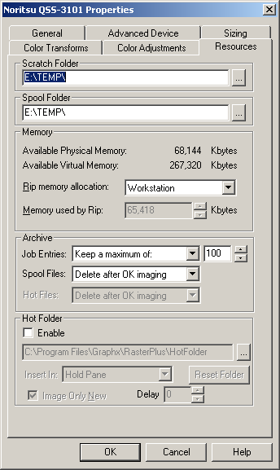
Spool Files:
Delete After OK imaging - delete the Application Print spool files if they have been imaged OK.

Delete on Job Entries delete - delete the Application Print spool files when the Job entry is deleted.
Hot Files:
Delete After OK imaging - delete Hot Files if they have been imaged OK.

Delete on Job Entries delete – delete Hot Files when the Job entry is deleted.
Never delete - never delete Hot files.
Hot Folder
Enable - If checked, RasterPlus will poll the Hot Folder for files to print. The folder can be selected in the edit box below this check box.

Insert In - What pane to insert the Hot Files.
Image Only New - If checked, RasterPlus will not insert the files it finds in the Hot Folder when the Resource Property Page is closed; only new files which appear in the Folder will be inserted into the appropriate Pane.

Color Transform Properties
(not available for all devices)
The RasterPlus Color Transforms Property Page lets you specify whether to use the TrueGraphx ICC color transform engine to alter the image data being sent to the device.

Connection Type
None ............................. No ICC color transform
ICC Profile ................... Use the ICC color profiles specified below
RGB Input
Specify the ICC profile which best describes the RGB color data in the job.
CMYK Input
Specify the ICC profile which best describes the CMYK color data in the job
Printer
Specify the ICC profile which best describes the current device characteristics. Select << Default Profile >> to force RasterPlus to use a default characterization.
Preview
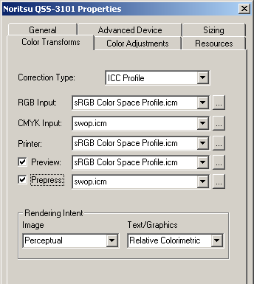
Specify the ICC profile which best describes the monitor on which RasterPlus will preview files. If checked, the color in the RasterPlus preview should be very close to the printed output
Prepress
Specify the ICC profile which best describes the press which you are trying to simulate. If checked, the color in the print you make on the selected RasterPlus device should be very close to press output.
Rendering Intent
You can specify different rendering intents for the images and text/graphics in your jobs.
The options are:
Perceptual This rendering intent should be used for photographic images. It preserves the relative relationship among the colors within the image so provides a pleasing reproduction of an image within the capabilities of the input and output device color spaces. Individual colors may not be reproduced exactly in order to maintain gradations and the relation among colors.
Absolute colorimetric This rendering intent is used when a specific color must be reproduced as accurately as possible. It preserves the exact reproduction of colors with a large dynamic range and color range. Colors that cannot be reproduced on the output device are reproduced as closely as possible.
Relative colorimetric This rendering intent is used when a specific color must be reproduced as accurately as possible. It preserves the exact reproduction of colors within the ranges of both devices. Colors outside of the ranges may map to a single color
Saturation This rendering intent preserves the vividness of an image and is used for graphics. It preserves the relative saturation of colors between the color ranges of the input and output devices. Colors outside the range are converted to colors with the same saturation at the edge of the range.

Sizing Properties
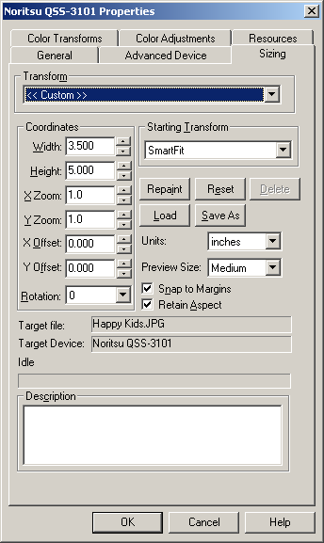
You may occasionally need to resize, crop, or place print Jobs before releasing them to the printer. You can do this by applying a Transform. A Transform is a set of sizing and placement values you apply to Queues or Jobs. Transforms are set from the Sizing Property page in Edit...Default Queue Properties or Edit...Job Properties.
RasterPlus comes with several pre-built Transforms that can be applied to Jobs or Queues:
None No Transform; the image is printed with its original size and position. This will work if the page size in the application, the page size in the driver used to create the print file, and the page size selected in RasterPlus all are exactly the same.
SmartFit Best fit the image into the device space; possibly resulting in borders on the top and bottom or sides. RasterPlus uses the PostScript bounding box, or bitmap image extents to compute the fit.

SmartCrop Expand the image to completely fill the media; possibly resulting in part of the image being cut off. RasterPlus uses the PostScript bounding box, or bitmap image extents to compute the cropping.

Flip (None) Flip the image 180 degrees after originally using no transform for initial sizing.
Flip (SmartFit) Flip the image 180 degrees after originally using a SmartFit transform.

Creating Custom Transforms
You can define a Custom Tranform by selecting <<Custom>>. This Custom Transform will be used only for the Queue (if you are doing Default Queue Properties) or the selected Job(s) (if you are doing Job Properties), however, you can save the Custom Transform to a named Transform that you can apply to other Queues or Jobs.
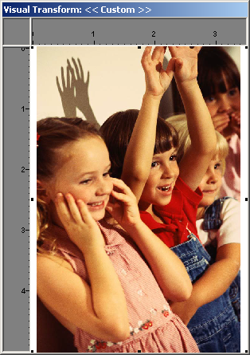

Editing a Custom Transform
You can change the following items in a Custom Transform:
Starting Transform-The initial Transform to use before applying the sizing values.
Width - Network Printing The actual width of the image. Modifying this has the same as modifying the X Zoom. Height - The actual height of the image. Modifying this has the same affect as modifying the Y Zoom.
X, Y Zoom - 1.0 is no zoom, fractions will make the image smaller and values greater than1.0 will make the image larger.
X,Y Offset - Offset the image in the horizontal or vertical direction. Rotation - Rotate the image counterclockwise in 90-degree increments. You will need to Repaint after setting rotation.
Description - A description you wish to associate with this Transform.
Snap to Margins - If set, the image will "snap" to the margins of the printable area when you drag it around.
Retain Aspect - Retain the aspect ratio of the image when zooming.

Click Repaint to see the image. You can use your mouse to move and the image on the screen or you can directly edit the sizing values.

The target device and file that you are using when defining the transform are indicated on the screen. Select Load to load an existing Transform. Select Save As to save this Custom Transform to a named Transform.

NETWORK PRINTING
If you depend on printer sharing in mixed operating system environments, then RasterPlus Windows Edition is the ideal choice to maximize your printer connectivity. RasterPlus is a true enterprise-wide network print server because its printers can be published to any Macintosh OS8.6 – 9.XX or Windows client. Simply File-Print from your favorite client application and RasterPlus will do the rest.

In addition to client network printing, you can use multiple hot folders with RasterPlus to process over 20 different file formats including PostScript, EPS, PDF, TIFF and JPEG. Just copy your files into the folder, and RasterPlus will immediately print.

Deciding which network print method to use depends on your workflow. If you want to print directly out of any client computer application, then you should configure Client-Host network printing. However, if you have print-ready files (like PDF, TIFF, or JPEG), it may be faster to simply copy the files into a hot folder for printing. Either way, the power of RasterPlus lets you do both at the same time.

Client-Host Network Printing

RasterPlus can be set up as a native Windows print server so configured printers can be shared with others on the network. Now anyone on the network who uses a Windows or Macintosh computer can use the power of RasterPlus with the simplicity of File-Print.

Although RasterPlus can be installed on all Windows versions, the print sharing services in each operating system may limit who can print to RasterPlus. The following compatibility guide outlines what operating systems the RasterPlus server supports.

WINDOWS 95/98/ME AS A HOST PRINT SERVER
If you install RasterPlus on Windows 95/98/ME, you can print from any other Windows 95/98/ME or Windows NT computer to the configured RasterPlus printers.

To install RasterPlus with network printing on a Windows 95/98/ME Host:
- Install RasterPlus on the Windows 95/98/ME computer, and install the desired printers in Windows. Make sure that the printer is directly connected to this PC.
- Enable printer sharing under Windows 95/98/ME. Go to the Windows control panel, and select the Network icon. Under the Configuration tab, click on the File and Print Sharing...button. Enable print sharing and click OK all the way out.
- Click on Start...Settings...Printers and right click on the printer icon of the printer you wish to share.
- Select the Sharing page.
- Give the printer a name that you wish others on the network to see.
Note: Do not put spaces or non-Alpha numeric characters in the name.

Now you can add the configured RasterPlus printer on any computer on the network.

Adding a printer to a Windows 95/98/ME network node:
- You must first map the drive of the Host computer that has RasterPlus installed to the Client computer you are adding the printer to.
- From the Client computer select Add Printer from the Windows Printer Control Panel and select Network Printer.
- Browse the network and select the printer you created on the Host Windows 95/98/ME printer server.
- When the installation prompts you for the driver, choose Have Disk, browse the network for the drive mapped in step one. Select the RasterPlus\CrossPlatform\95 (98)/ME directory. Choose your printer from the list and select OK. Otherwise, the contents of this directory can be copied to a floppy disk and used.
- Continue with the installation by selecting Next on every page.
Adding a printer to a Windows NT/2000/XP2003 network node:
- You must first map the drive of the Host computer that has RasterPlus installed to the Client computer you are adding the printer to.
- From the Client computer select Add Printer from the Windows Printer Control Panel and select Network Printer.
- Browse the network and select the printer you created on the Host Windows 95/98/ME printer server.
- When the installation prompts you for the driver, choose Have Disk, browse the network for the drive mapped in step one. Select the appropriate RasterPlus\CrossPlatform\NT\2000\2003 directory. Choose your printer from the list and select OK. Otherwise, the contents of this directory can be copied to a floppy disk and used.
- Continue with the installation by selecting Next on every page.

WINDOWS NT/2000/XP/2003 AS A HOST PRINT SERVER
If you need a complete cross-platform imaging system, you can install RasterPlus on a Windows NT 4.0/2000/XP server. This will enable you to Chooser-Print from any Macintosh OS8.6 – 9.XX on the network and File-Print from any Windows PC.

Note: If RasterPlus is installed on a Windows NT workstation, you will only be able to print from other Windows NT machines. For cross-platform support of Macintosh and Windows 95/98 machines, you must use Windows NT server or install PC Maclan from Miramar Systems.

Installing RasterPlus with network printing on Windows NT Server:
- You must first log on as administrator.
- Install RasterPlus on the Windows NT/2000/XP/2003 server computer, and install the desired printers in Windows.
- Click on Start...Setting...Printers and right click on the printer icon of the printer you wish to share.
- Select the Sharing page.
- Give the printer a name that you wish others on the network to see. (Note: Do not put spaces or non-Alpha numeric characters in the name.) Now you can add the configured RasterPlus printer from any computer on the network.
- Right click on the same printer icon and click Document Defaults and click Advanced. This section allows you to set the defaults for the printer.(print preferences in Win2000/XP/2003. Now you can add the configured RasterPlus printer from any computer on the network.

Adding a printer to a Windows 95/98/ME network Client:
- You must first map the drive of the Host computer that has RasterPlus installed to the Client computer you are adding the printer to.
- Select Add Printer from the Windows Printer Control Panel and select Network Printer.
- Browse the network and select the printer you created on the Windows NT server. Click OK and select Next.
- When asked for the printer disk click Have Disk and browse the network for the drive mapped in step one. Select the appropriate RasterPlus\Cross Platform folder: If installing on Windows 95, select 95, if installing on Windows 98, select 98, or copy the contents of the appropriate directory to a floppy disk and use that on each machine.
- Continue with the installation by selecting Next on every page.

Adding a printer to a Windows NT network node:
- You must first map the drive of the Host computer that has RasterPlus installed to the Client computer you are adding the printer to.
- From the Client computer select Add Printer from the Windows Printer Control Panel and select Network Printer.
- Browse the network and select the printer you created on the Host Windows NT/2000 printer server.
- When the installation prompts you for the driver, choose Have Disk, browse the network for the drive mapped in step one. Select the RasterPlus\CrossPlatform\NT directory. Choose your printer from the list and select OK. Otherwise, the contents of this directory can be copied to a floppy disk and used.
- Continue with the installation by selecting Next on every page.

Adding a printer to a Macintosh network node:
- When a printer is installed from within RasterPlus, a PPD file is created and copied to the Program Files\Graphx\RasterPlus\Cross Platform\Mac. Before installing the printer on a Mac, the PPD should be placed in the System\Extensions\Printer Descriptions folder.
- From the Chooser, select the LaserWriter 8.
- The printer(s) you've installed and shared on the NT machine will be listed under the Select a PostScript Printer section. Select the desired RasterPlus configured printer and click Create. From the Printer Descriptions folder select the appropriate PPD.
- The printer will now be listed as a Desktop Printer and you can print to the selected RasterPlus printer from any Macintosh application.

Note: that you must have Services for Macintosh installed under Windows NT server in order to network print and use file services from any Macintosh on the network.

HOT FOLDER PRINTING
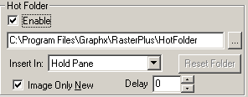
RasterPlus lets you use multiple hot folders to process over 20 different file formats including PostScript, EPS, PDF, TIFF and JPEG. Just copy your files into the folder, and RasterPlus will immediately print.

When RasterPlus detects a new file in the hot folder, it automatically inserts the file into the print queue. The default Queue Properties will be applied to all files added to the hot folder. Therefore, you can specify the exact file print properties for all your files.

You can set up multiple hot folders with RasterPlus by simply opening a new print queue and selecting a different hot folder. By assigning unique properties to each print queue, you can easily tailor how each hot folder will print.

Configure
- Select Edit...Queue Properties. Click on Resources tab.
- Under Hot Folder, click Enable.
- Select a polling Hot Folder by clicking the ... button.
Networking Note: The hot folder can be anywhere on the host machine or the network. However, we recommend keeping the hot folder on a hard drive in the host machine and copying files from the client computers.
- Select whether hot folder files should enter the Hold Pane or be printed automatically. Click OK.
Note: The Image Only New option will prevent processing any files already in the hot folder when RasterPlus is first launched.

Digital Package Printing

Some printers in RasterPlus feature digital package printing - the ability to make multiple digital reprints of an image on the same page. Regardless of the original image size, RasterPlus will automatically orient and resize an image to fill each frame on the page. The result is a photo package ready to cut into 8x10, 5x7, 4x6 or wallet prints.

Traditionally, photo labs would use large optical machines to produce package pages for their portrait, wedding, and educational photographic customers. However, the advent of high-quality color digital printers teamed with powerful imaging software like RasterPlus and PackagePlus, has changed the nature of the business. Now you can make packages with all the speed and quality of the old mechanical methods, but with more flexibility and with significantly lower hardware costs using digital processing.

Package printing is included in select RasterPlus printers, allowing you to:

- Use dozens of included single sheet packages to create photographic prints that include 12x18, 8x10, 5x7, 4x6, 3.5x5 and wallets.
- Easily create packages in RasterPlus from all supported file formats, including PostScript, JPEG, PDF, and TIFF.
- Automatically orient, size, and crop the image to fit each photographic frame on the page. The aspect ratio of the original file is always maintained, with cropping done (if needed) to the center of the image.
- Print packages directly from any Windows or Macintosh application. Simply create your page to the largest image on the package and print.
- Preview all packages in RasterPlus before they are printed.
- Easily change package types for any file in the print queue.
- Automatically print packages from files copied into a Hot Folder.
- RasterPlus Windows Edition enables package pages to be published across a network so that connected users can package print from their applications.

Contact your dealer or Sales@Graphx.com for information on PackagePlus to create your own custom packages.
Package Printing from the RasterPlus Print Queue
Any file that is in the RasterPlus print queue can be made into a package print. In order to create a package print within RasterPlus:
- Add a file (like a JPEG or TIFF) to the print queue.
- Select Edit. Default Queue Properties (optionally select Edit. Job Properties for a specific Job). Under Media, select the desired package. For example, P-LTR (1) 5x7 (4) wallets will print a package page of one 5x7 and four 2.5x3.5 wallets on Letter paper as shown below.
- Preview the selected Job and verify the package page.
- Print the Job.

Package Printing from an Application to RasterPlus
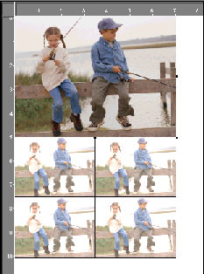
The package pages available within RasterPlus Windows Edition are also provided in the application print driver. In order to print packages directly from any Windows or Macintosh application to RasterPlus Windows Edition:
- Open the desired application and document.
- From the desired application, select Page Setup. Enter a document page size that corresponds to the largest image on the RasterPlus package page. For example, if your package page is one 5x7 and four wallets, enter 5 inches by 7 inches as your document page size.
Note: RasterPlus creates a package print by sizing and rendering the original document to the largest frame on the page.
- Select File Print and select the RasterPlus printer. Click on printer properties to specify the package page that matches the document setup and then print.

IMPORTANT NOTICE: If you are sharing a RasterPlus printer over a network, the packages are shared as well. If you add, delete or modify packages, you need to re-publish your print driver and re-install the driver on any connected node. To re-publish the printer in RasterPlus, select the appropriate print Queue and then select Printer. Reinstall Application Print Driver. Any connected users must then re-install this new-shared print driver.

PACKAGEPLUSTM - CREATE CUSTOM PACKAGES
PackagePlus is additional software available from Graphx that lets you create your own photo packages for RasterPlus Windows and Macintosh print software. Using a canvas based on any printer page size, you can place an unlimited number of image frames on the same page. In addition, you will be able to:

- Apply an image overlay, like a logo or custom border created in PhotoShop, to each frame on the page. RasterPlus automatically sizes the overlay for each print, taking advantage of alpha channel information for transparent fades.
- Select the cropping intent for each image frame on the page to automatically crop favoring the center, left, right, top or bottom.
- Create your own packages to any RasterPlus package-friendly printer page.
- Place an unlimited number of image frames on the page in any orientation, size and location.
- Group pages together to automatically print a collection of package sheets in one click.

Installing PackagePlus during the RasterPlus Installation
During the RasterPlus installation, you will be able to check a box that causes the optional PackagePlus application to install. At the end of the RasterPlus installation, the PackagePlus installation will start. You will be prompted to enter a serial number. Please enter the serial number listed at the bottom of your PackagePlus document.

Installing PackagePlus after the RasterPlus Installation
If you did not optionally install PackagePlus during the RasterPlus installation you will need to re-run the PackagePlus portion of the RasterPlus installer to correctly install PackagePlus. To do this:
- Put the RasterPlus CD in your CD drive.
- Cancel the RasterPlus installer program if it automatically starts.
- Use Explorer to browse to the PackagePlus folder on the CD.
- Double click setup.exe

The PackagePlus installation will start. You will be prompted to enter a serial number. Please enter the serial number listed at the bottom of your PackagePlus license document or type Demo.
Using PackagePlus
Select Start...Programs...Graphx...PackagePlus from the Windows taskbar. The application is displayed with two panes within the window.

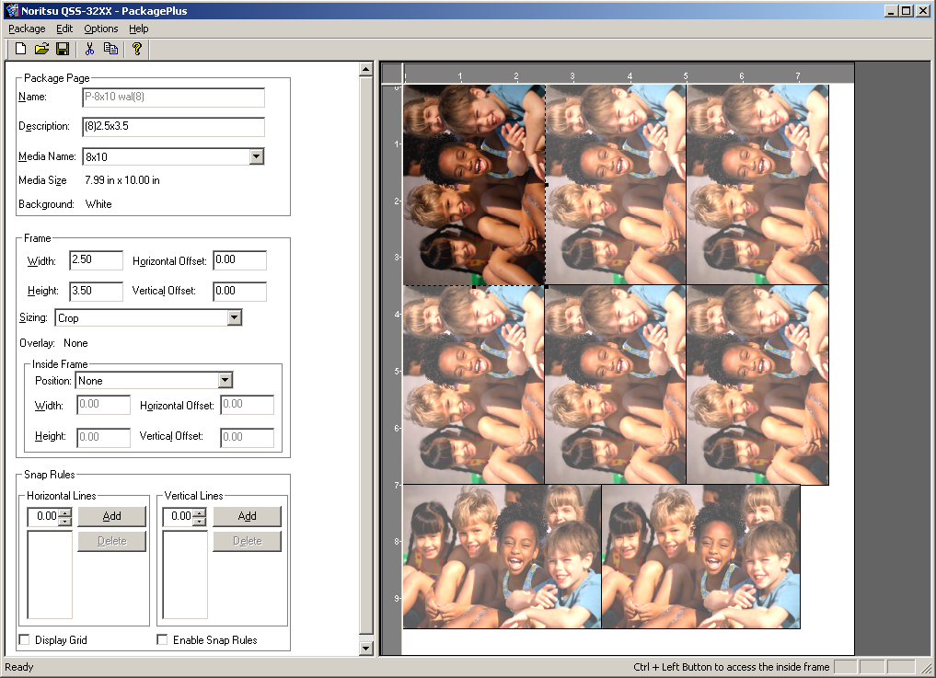

- The pane on the left is the Data information dialog. The Data information dialog contains information about the package and the selected frame. This information can be changed which will modify the associated item in the Canvas.
- The pane on the right is called the Canvas. The Canvas represents the package page into which you will add Frames. Frames represent copies of the same photo.

Packages
A package can consist of a single page or contain multiple pages. A package containing multiple pages is referred to as a package set. PackagePlus comes with standard packages consisting of a single page that can be modified or used as a template to create new packages.

Modifying an existing Package
In order to modify an existing package:
- Set the Printer and Package Name you wish to edit.
- Edit the package as desired (add, delete, resize, and move Frames).
- Select Save Package from the Package menu and the package page will be saved.

Creating a new Package Page
- Create from scratch
  - Set the Printer and select New Package...Page from the Package Menu.
  - A blank page with no frames will be presented.
  - Enter a name and optionally a description.
  - Select the Media for the package Canvas.
  - Edit the package as desired (add, delete, resize, and move Frames).
  - Select Save Package from the Package menu and the package page will be saved.
- Create from an existing package
  - Set the Printer and Package Name you wish to use as a template.
  - Select Copy Package from the Package menu. This will create a duplicate of the current package with `Copy' appended to the name.
  - Modify the name
  - Make the changes that you desire to the template.
  - Select Save Package from the Package menu and the package page will be saved.

Note: Alternately you could also make changes to the package that you are using as a template and select Save Package As... from the Package menu.

Adding Frames
This process may be accomplished using various techniques.
- Select Add Frame from the Edit menu OR
- Click on the canvas and drag the mouse OR
- Click on the canvas and pressing Insert

Resizing a Frame
This process may be accomplished using various techniques.
- Editing the width or height in the data pane OR
- Click the mouse on a resize block and drag OR
- With the keyboard.
- Select the frame in the canvas
  - Use the UP arrow to increase the height
  - Use the DOWN arrow to decrease the height
  - Use the RIGHT arrow to increase the width.
  - Use the LEFT arrow to decrease the width.

Moving a Frame
This process may be accomplished using various techniques.
- Edit the Horizontal or Vertical offset in the data pane OR
- Click the mouse inside the frame and drag OR
- With the keyboard
  - Select the frame in the canvas. The selected frame is brighter.
  - Use the SHIFT + UP arrow to move the frame up.
  - Use the SHIFT + DOWN arrow to move the frame down.
  - Use the SHIFT + RIGHT arrow to move the frame right.
  - Use the SHIFT + LEFT arrow to move the frame left.

Deleting Frames
- Select the frame you wish to delete. The selected frame is brighter.
- Select Delete Frame from the Edit menu or
- Press the Delete Key

Inside Frames
It is possible to create a frame within a frame. This feature allows you to easily create a bordered print or to position an image anywhere within the existing frame.

Adding an Inside Frame
This process may be accomplished using various techniques.
- Click on an existing frame
- In the Data pane select the position for the inside frame. This will create a default frame that can be modified. The position options are:
  - None: Frame contains no inside frame
  - Border: Inside frame is initially centered within the frame. The overlay is mapped to the inside frame.
  - Center: Inside frame is initially centered within the frame. The overlay is mapped to the original frame.
  - Top Left: Inside frame is positioned in the top left corner of the original frame.
  - Bottom Left: Inside frame is positioned in the bottom left corner of the original frame.
  - Top Right: Inside frame is positioned in the top right corner of the original frame.
  - Bottom Right: Inside frame is positioned in the bottom right corner of the original frame.
  - Float: Inside frame is originally positioned in the center but can be placed any where within the original frame.
- Alternately, you can click inside an existing frame, press and hold the CTRL key and drag the mouse. This will create an inside frame defined as `float'.

Resizing an Inside Frame
This process may be accomplished using various techniques.
- Edit the Width or Height in the data pane:
- Press and hold the CTRL key click the mouse on a resize block and drag OR
- With the keyboard:
  - Select the frame in the canvas
  - Use the CTRL + UP arrow to increase the height
  - Use the CTRL + DOWN arrow to decrease the height
  - Use the CTRL + RIGHT arrow to increase the width.
  - Use the CTRL + LEFT arrow to decrease the width.

Moving an Inside Frame
This process may be accomplished using various techniques.
- Edit the Horizontal or Vertical offset in the data pane:
- Press and hold the CTRL key click the mouse inside the frame and drag OR
- With the keyboard:
  - Select the frame in the canvas
  - Use the CTRL + SHIFT + UP arrow to move the frame up.
  - Use the CTRL + SHIFT + DOWN arrow to move the frame down.
  - Use the CTRL +SHIFT + RIGHT arrow to move the frame right.
  - Use the CTRL + SHIFT + LEFT arrow to move the frame left.

Removing an Inside Frame
    - Select Position None.

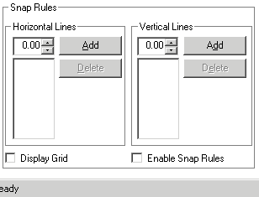
Snap
You can add rules that will make the frames stick to the edge of the media and to any rules that you define. To add rules enter a value for either a horizontal or vertical line and click Add. To delete rules, select the Rule and click Delete.

To view the rules that have been added click the Display Grid check box. Vertical and Horizontal lines will be displayed on the canvas representing the defined rules.

To make the frames stick to the edge of a defined rule click the Enable Snap Rules check box. The frames will snap to the rules whether or not the Display Grid is checked.

Setting the Sample Frame Image
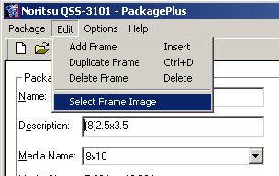
You can change the Image displayed in the frames of the sample package.

Select Edit…Select Frame Image. This will display an open dialog box. Select the desired JPEG or TIFF and press OK.

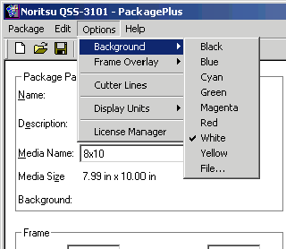
Setting A Background

You can change the Background of the non-photo area of your package. The background can be set to one of eight colors or a selected Targa file.

Select Options…Background. Select the background color desired or select File. Selecting file will display an open dialog
box. Select the desired Targa file and press OK.

USING PACKAGEPLUS CUSTOM PACKAGES

Installing Custom Packages
If PackagePlus is installed on the same computer as RasterPlus, the custom packages are automatically available in RasterPlus. However, if you have installed PackagePlus on a separate computer from RasterPlus you must copy the PackagePlus template files (.ini) to the computer where RasterPlus is installed to make them available for selection.
- Exit PackagePlus and RasterPlus.
- Copy the PackagePlus template file (.ini).
  - The template file is located in a directory under the PackagePlus installation directory. (e.g. c:\Program Files\Graphx\PackagePlus\Printer Name)
  - The Printer Name (e.g. Noritsu) is based on the PackagePlus target printer.
- Paste the copied PackagePlus template file into RasterPlus.
  - The template file must be pasted into a directory under the RasterPlus installation directory (e.g. c:\Program Files\Graphx\PackagePlus\Printer Name)
  - The Printer Name directory must be the same as the directory in PackagePlus.
  - The template file will replace a file of the same name.
- Start RasterPlus and the new packages will be available in the Media Size selection on the General tab within the Properties dialog box.

Creating and Using Package Frame Overlays
PackagePlus lets you specify an overlay image that automatically gets layered on top of each photo frame of the package. For example, with a frame overlay you can specify a frame or company logo that automatically gets applied to each photo in the package.

PackagePlus includes some sample overlays. Frame overlays can be created in any photo editing software, like Adobe PhotoShop, that supports 32-bit Targa files with Alpha channels. The Alpha channel controls the degree to which a given part of the image will be transparent.

Overlays are images that can be applied on top of the image frame on a Package. One overlay can be specified for each package page. The overlay can use alpha channels for "knock-out" areas. An overlay file must be a 32-bit Targa file.

To create an overlay in Photoshop for use with PackagePlus:
- Open or create an RGB image in Photoshop. If the image is not in RGB mode, choose Image...Mode...RGB color 8 Bits per channel.
- Use the Marquee tool to select the area of the image you want to remain opaque (not transparent.) In most cases you will need to make a selection, then select the inverse of that selection.
- Once selected, choose Select...Save...Selection (a save selection window will appear.)
- Choose Select...Channel...New from the operation section then click OK.
- Choose File...Save A Copy.
- Enter the desired name and destination then select Targa as the File Format. Click OK. Be sure the Exclude Alpha Channels option is unchecked.
- When presented with the Targa options window, select 32 bits/pixel then click OK.

You have now created a custom overlay that may be attached to any package in Package Plus. Photoshop uses the information in the fourth channel to create the alpha channel. If your new channel is not listed in the fourth position in the Channels palette, drag the channel within the palette to the fourth position.

EXAMPLE: To create a simple oval frame:
- Create a new page whose aspect ratio (height/width) matches the ratio of the page to which you will apply the overlay. PackagePlus will scale the overlay to match the page so the overlay can be smaller or larger than the page.
- Use the ellipse tool to draw a shape that will become the window or mask that reveals the photograph or image in the package. Inverse selection.
- Choose Select...Save Selection and save without entering a name. This creates a channel mask
- Choose Select...Inverse to select the OUTER part of the selection
- Fill the image with a solid color or pattern
- Flatten or merge any layers you may have created for text or other objects.
- Choose ...
- Type in a file name and select Targa as the output option
- Click 32 bits in the next dialog and click OK.

Using an Overlay
From the Options menu select Frame Overlay.
- Select None to remove an overlay or select File...
- Selecting file will display an open dialog box.
- Select the desired Targa file and press OK.

Enabling the Fotoba grid
PackagePlus can automatically create cut lines that are recognized by the Fotoba Digitrim. Your output is ready to be precisely cut into individual prints.

From the Options menu select Cutter Lines to render the grid lines in your final output.
Note: the package frames you create must be 6mm apart and 3mm from the edge of the page or PackagePlus will not save the file.

Select Cutter Lines after creating the package and before saving.

TrueGraphx Color Management System

ICC COLOR TRANSFORMS WITH TRUEGRAPHX
An integral part of professional printing is accurate color reproduction. RasterPlus achieves this using TrueGraphx, a color system that uses ICC (International Color Consortium) color profiles. ICC color profiles define the color space of the various components of your system (i.e.: display and printer) so that the printed output has the color that you expect.

The TrueGraphx color system links together any ICC profiles for accurate results from a given combination of paper, ink and printer.

- Input RGB profile: describes the input RGB color space, usually your monitor. RasterPlus has a generic input RGB color monitor profile, but you can replace this with your own color monitor profile if supplied by the manufacturer.
- Input CMYK profile: describes how the CMYK colors in the image would look if printed to a well-defined CMYK device.
- Printer profile: describes the device to which you are printing. The profile should take into account particulars about the device, the media, and the ink. RasterPlus has profiles for the various printers, inks and media. The name of the included printer profiles have the format: PrinterModel_Media_Ink Reduction Factor_ Ink_DateCreated.icc. For example, "Pro_PGlossy_100_GA_0829.icc" is for an Encad Pro series, Photo Glossy media, and Encad GA ink.
- Monitor Profile (Preview): describes the local monitor of the computer on which RasterPlus is installed. The Preview Monitor Profile is used to color manage the print previews in RasterPlus.
- Press Profile: If your goal is to match a specific offset press, you need to select a profile for your press. RasterPlus ships with a set of standard SWOP printer profiles.

CREATING NEW ICC PROFILES
RasterPlus includes a set of ICC profiles for specific printers generated using Monaco® profile generation software. If you wish to create a new printer color profile, you'll need to create it using either Monaco or similar ICC profile creation software.

In order to create a new ICC profile, you should print the profiler-supplied targets (usually using a setting of ANSI A paper size and "None" Transform) with ICC color management turned off in RasterPlus.

RENDERING INTENT STYLES
In addition to the ICC Profile TrueGraphx provides the ability to individually set the rendering intent of images and text/graphics in any given file. RasterPlus lets you set different rendering intents for images and text/graphics in any given job. Rendering intent settings are only available when ICC color profiles are being applied.

A rendering intent defines the way the color transformation from the device color space to the CIE Lab color space and vice versa is performed. It is easy to imagine that there are different methods for mapping the rather large RGB color space of a scanner to the smaller CMYK color space of a printer.

How this mapping should be performed depends on the color information you have: a photo, a company logo or business graphics.

Perceptual
This rendering intent should be used for photographic images. It preserves the relative relationship among the colors within the image so provides a pleasing reproduction of an image within the capabilities of the input and output device color spaces. Individual colors may not be reproduced exactly in order to maintain gradations and the relation among colors.

Absolute colorimetric
This rendering intent is used when a specific color must be reproduced as accurately as possible. It preserves the exact reproduction of colors with a large dynamic range and color range. Colors that cannot be reproduced on the output device are reproduced as closely as possible.

Relative colorimetric
This rendering intent is used when a specific color must be reproduced as accurately as possible. It preserves the exact reproduction of colors within the ranges of both devices. Colors outside of the ranges may map to a single color.

Saturation
This rendering intent preserves the vividness of an image and is used for graphics. It preserves the relative saturation of colors between the color ranges of the input and output devices. Colors outside the range are converted to colors with the same saturation at the edge of the range.

Connecting Your Device

SCSI
The SCSI interface is designed to send data very quickly back and forth along a SCSI chain. Up to eight devices can be attached to any SCSI chain (this number includes your computer, its hard drive, and if you have one, your CD Rom drive).

SCSI Rules
- Turn off all devices in the chain before connecting or disconnecting the SCSI cables.
- Turn on the last device in the chain first and your computer last.
- The computer must be off; the computer sends two hot lines down its SCSI cable. Make certain the computer has powered down before making changes. If you intend to change a SCSI device (for example: move it, or change its ID) you must also make sure the device is turned off.
- There can be only one; The SCSI controller (computer) needs to be in constant contact with its devices. If more than one computer attempts to connect to a device you will terminally confuse both controlling computers. You cannot use a switch box with SCSI based devices.
- The Total length must be 19.7' or less; each length of cable between devices must be no longer than 6' and the shorter the better. Cables longer than 6' cause the introduction of too much noise in the SCSI signal. For the best results (highest speeds, and lowest error rates) make sure that you use Premium SCSI cables. We recommend Apple certified or certificate approved premium cables.
- Each device must have a unique ID; on the back of most SCSI devices is a switch or indicator that allows you to set its ID number. This number can be set to any legal number (0-7), and has no bearing on the order devices are attached to your SCSI chain. There are a few reserved numbers you need to avoid using: Your adapter is ID 7, it's hard drive is usually ID 0 and traditionally CD ROMs are ID 3. This leaves IDs 1,2,4,5,6 available to use.
- There must be termination at the ends; you must supply the terminator at the end of the SCSI chain of devices. Terminators do two things: 1) Filter the signal to keep the signal-to-noise ratio high and 2) Keep the signal from bouncing back to the source. Refer to your printer manufacturer for the recommended SCSI termination.

SCSI under Windows 95/98
RasterPlus uses the Windows 95/98 built-in ASPI manager, so no additional software is needed. To properly configure the driver, you should connect your printer, power-on your printer (as well as any other devices connected to the SCSI board) and then power on your PC. Windows 95/98 may prompt you for a Windows 95/98 driver for the SCSI device at start up. If this happens, simply select Next and click OK.

SCSI under Windows NT 4.0/2000/XP/2003
Windows NT does not have a built-in ASPI manager. To install the ASPI manager, you need to either:
- Install EZ-SCSI (included with Adaptec SCSI cards), OR
- Install the NT ASPI manager found on the RasterPlus setup disk under the \ASPI directory, OR
- Download the NT ASPI manager setup program, ASPI32.EXE from the Adaptec web page (www.adaptec.com).

ASPI layer version with Windows 2000/ME Warning!
Adapatec states that ASPI layer version 4.60 (1021) is for Windows 9x and Windows NT only. They say NOT to install ASPI32.EXE with Windows 2000\ ME. The reason is that operating systems have their own ASPI layers which conflict with ASPI32.EXE."Windows 2000's HAL, (hardware Abstraction Layer,) initiates the ASPI layer and with both versions attempting to load, the operating system will fail.

At this time we can only say that RasterPlus needs this ASPI layer to properly communicate with the SCSI devices that we support. Installing the file may interfere with other programs or devices.

RasterPlus SCSI Explorer
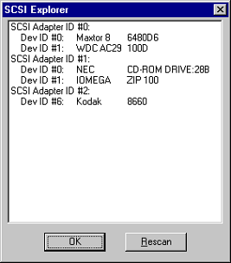
RasterPlus has a built in SCSI Explorer to help you manage all of your attached SCSI devices. To use the SCSI Explorer, you must first install the appropriate SCSI software. The SCSI Explorer tool can then be activated from Tools...SCSI Explorer within RasterPlus.

The SCSI Explorer on the right shows a Kodak 8660 with SCSI Adapter (HostID) of 2 and SCSI ID (DevID) of 6.

The SCSI Explorer will identify all the SCSI cards and devices installed on your system. A unique SCSI Adapter ID will identify each card. If devices are attached to a SCSI card, they will be shown by a Dev ID.

Both the SCSI Adapter ID and the Dev ID are critical in configuring RasterPlus to correctly print to the desired device. The appropriate Dev ID number should be entered under Queue Properties...General...Connection. The appropriate SCSI Adapter ID should be entered under Queue Properties...Advanced Device...SCSI Adapter.

SCSI Troubleshooting
Problem:
When you boot Windows 95 with your printer connected via SCSI to your PC, a blue screen appears and Windows fails to boot.
Probable Cause:
There is a known bug in the Windows 95 IOS.VXD system file that prevents Windows 95 from booting with a SCSI printer connected.

Possible Solution:
In the "Drivers, patches and Sample files" section of the Microsoft web site, look for "Microsoft SAME IDE Channel N CDROM & Hard Drives". Selecting this will download a file IOSUPD.EXE. Execute this file to upgrade the virtual driver IOS.VXD and this will fix the problem.

Problem:
When you boot Windows 95 with the printer connected via SCSI to your PC, Windows fails to boot.
Probable Cause:
Your low-level SCSI card drivers need to be updated.

Possible Solution:
Obtain new drivers from your SCSI card manufacturer.

Problem:
RasterPlus does not "see" the attached printer.
Probable Cause:
Many

Possible Solutions:
You may have multiple SCSI adapters or an EIDE card (which appears like a SCSI Adapter to Windows). You must thus change the Adapter ID from 0 to another ID. You do this from RasterPlus by selecting Queue Properties, clicking on the Device tab, and selecting Options. Change the "SCSI Adapter #:" setting to another number (usually 1). You can use the SCSI Explorer in RasterPlus Tools to find out what SCSI Adapter # to use. Select the Host ID # that has your SCSI device listed.

Make sure that the SCSI ID (e.g.: SCSI1:, SCSI2:, etc.) that you set in the print driver or in RasterPlus Queue Properties matches the SCSI ID of the printer. Please consult the printer manual for more information on setting the device SCSI ID. The SCSI ID must be unique-not used by any other device.

Make sure that you power on each SCSI device starting with the device furthest from the PC and work toward the PC. For example, if your PC is connected to a SCSI printer, and the SCSI printer is connected to a SCSI ZIP drive, first power up the ZIP drive, then the printer and finally the PC, in that order.

Make sure that the last SCSI device in the chain is terminated.

If you have internal SCSI devices (e.g.: a SCSI hard disk or SCSI CD-ROM), the SCSI card should have Host Adapter termination disabled. If you do not have internal SCSI devices, your SCSI card should have Host Adapter termination enabled. You can enable or disable Host Adapter termination at PC boot time with some Adaptec SCSI cards using the SCSISelect utility. The latest Adaptec SCSI cards can actually automatically enable/disable internal termination. Please refer to your SCSI documentation for more information on internal termination.

Problem:
The first time you run Windows 95 after connecting a SCSI printer, you may receive the message: "A new device has been found, insert..."
Probable Cause:
Windows has found a new SCSI device
Possible Solution:
Select "Do not install a driver (Windows will not prompt you again)", and click OK. The prompt will not come up again. In newer versions of Windows you must click Next and Finish up to eight times before you will not be prompted again.

Problem:
A fault occurs when you launch RasterPlus in Windows NT 4.0
Probable Cause:
You don't have the ASPI SCSI driver for Windows NT installed.
Possible Solution:
Unlike Windows 95, Windows NT 4.0 does not have a built-in ASPI manager. Refer to the SCSI Under Windows NT4.0 section in this chapter on how to properly install the ASPI manager.

GPIB
GPIB requires the purchase of an add-on card, like the industry standard National Instruments PCI card. Check the printer manufacturer's documentation to see which board is right for your system.

GPIB Rules
- Each device must have a unique ID number; you can have up to 30 ID numbers on a GPIB chain. Every device needs a unique ID number. You set the ID in two places: 1) on the actual device itself (check your device's User's Guide for information on how to set its GPIB address); and 2) on the controlling computer's Handler software. You can have more than one computer on a GPIB chain, but only one computer can be a controller at a time.

Some devices use more than one address simultaneously. This is called `Secondary Addressing'. When setting up addresses on GPIB chains the standard convention is to set all device Primary Address IDs to even numbers. If you have any devices that require Secondary Addresses assign them the odd number that follows the device Primary Address. (Example: if your device has a Primary Address of 6, its Secondary Address should be set to 7.)

Consult the User's Guide that shipped with your device for more information on setting the Secondary Address. Not all devices support the use of Secondary Addressing.

- Devices must be no more than 13 feet apart; Devices can be attached almost any way you choose, except in a circle. You can daisy-chain, connect them in a star configuration or some of both. The computer can be in the anywhere on the chain. See the User's Guide that came with your GPIB card for more information on how to set up a GPIB chain. The maximum cable distance between any two devices cannot be more than 13 feet.

- The entire chain must be less than 60 feet; from one end to another, the entire chain must be less than 60 feet long. See the User's Guide that came with your GPIB card for more information.

Installing a GPIB Interface Board
Before using RasterPlus with GPIB devices, make sure that you have a National Instruments 488.2 GPIB board. Some older PC2, PC2A, and AT-GPIB boards are 488.1 and must be upgraded for use in Windows 95or NT. If you have a DOS GPIB driver with a version starting in C or E, you probably have a 488.1 board; contact National Instruments (1-800-IEEE-488) for further assistance.

GPIB Interface Software for Windows NT 4.0/2000
Contact National Instruments at 1-800-IEEE-488 for NT drivers if you don't already have them. You can also access these drivers through the Graphx web site at www.graphx.com.

GPIB Interface Software for Windows 95/98/ME
In order to use RasterPlus with your GPIB board in Windows 95, you'll need to install one of two sets of National Instruments Windows 95 drivers depending on the board you have:
- A Windows 3.1 driver and Windows 95 Compatibility drivers, OR
- A true Windows 95 driver

Windows 95 Compatibility Drivers
If you have a PC2, PC2A, AT-GPIB (non-NT), or MC-GPIB GPIB card, you must install the standard Windows 3.1 GPIB drivers and then install the Windows 95 compatibility driver set. The compatibility driver set includes the GPIB-32.DLL and GPIB-16.DLL files and provides a 32-bit layer that translates 32 bit data and commands used by the standard Windows 16 bit drivers. The Windows 3.1 drivers and Windows 95 Compatibility drivers are available from the National Instruments FTP site or BBS.

Important Notes on Installing Compatibility Drivers
- Make sure that the Compatibility drivers are installed AFTER installing the standard Windows 3.1 drivers.
- The Compatibility installer actually only copies the necessary files: GPIB-16.DLL and GPIB-32.DLL into the \COMPATIBILITY directory on your hard disk. You must then PHYSICALLY COPY GPIB-16.DLL and GPIB-32.DLL FROM THE \COMPATIBILITY DIRECTORY to your \WINDOWS\SYSTEM subdirectory before using RasterPlus.

If you have questions, please contact National Instruments at: 1-800-IEEE-488.

True GPIB Windows 95 Driver
If you have an AT-GPIB TNT, AT-GPIB TNT+, AT-GPIB TNT PnP, GPIB-PCMCIA or GPIB card, you can install the true 32-bit Windows 95 driver. The true Windows 95 driver is available from the National Instruments FTP site or BBS. You can get the Windows 95 GPIB drivers from National Instruments FTP site at www.natinst.com.

Win2000/ME
Go to the National Instruments website <www.ni.com> for information.

Device Notes

BitmapPlus
BitMapPlus outputs raster files of any resolution and page dimensions selected by the user. The resulting files can be sent to print drivers or RIPs for large-format inkjet printers, large-format photographic printers, or large-format film recorders. All RasterPlus functions are available including Application Printing, Network Printing, Drag and Drop Printing. Files created by BitMapPlus can be used creatively in a wide variety of custom imaging configurations. It adds significant value to systems where existing printing software lacks sophisticated performance and throughput capabilities. The customer must provide customer ICC profiles that can then be enabled in BitMapPlus.

Basic setup
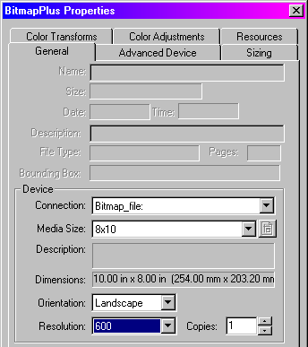
Go to BitMapPlus Properties...General, select one of the existing Media Sizes and Resolutions. A small number of default settings are available during the first use of the application following installation. Most likely, you will want to create custom sizes that will be available here.

Selection of Output file type
Go to BitMapPlus Properties...Advanced Device and select a file type from the pull-down menu. The choices include: TIFF LZW Compressed RGB, TIFF Uncompressed RGB, Targa Compressed RGB, Targa Uncompressed RGB, TIFF LZW Compressed Mono, TIFF Uncompressed Mono, Targa Compressed Mono, Targa Uncompressed Mono, JPEG RGB, and TIFF Uncompressed CMYK. When selecting JPEG, the JPEG Quality pull down is available where compression values ranging from 0 to 10 can be selected. Value 6 is the default.

Select an option for Output Filename: source name prefix, Prompt for name, or Unique filename. Enter a destination for the file that will be created by BitMapPlus on a local or network location.

Setting custom resolution and page size
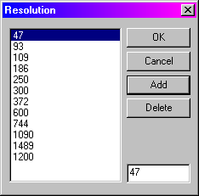
In BitMapPlus Properties...Advanced Device click Custom Res. This launches a Resolution dialog box that displays the resolutions that are currently available. Enter a new value in the blank field and click Add to add it to the list.

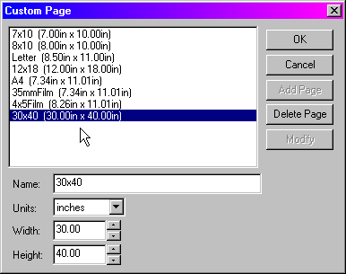
Similarly, click Custom Page that opens a dialog box showing the available page sizes. In the boxes below enter a Name, Width, and Height of a new page. Click Add Page, Delete Page, or Modify as necessary.
Package Printing with BitMapPlus

BitMapPlus supports Graphx PackagePlus, a separate application for making custom photo packages with image overlays.

Minilabs

Agfa
RasterPlus supports the Agfa d-lab.1 d-lab.2, d-lab.3, MSC.d with FIT minilabs.

Note: The d-Workflow must be installed and accessible from the PC where RasterPlus is installed.

Installation
- Open RasterPlus. Create a queue for the appropriate device.
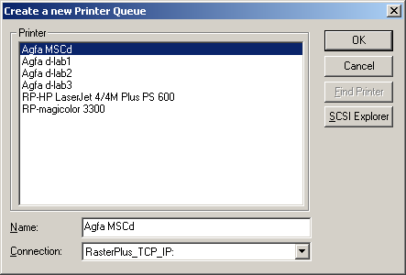
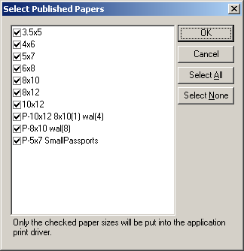
- Select the paper sizes that should be available to the print driver.

- Click OK.
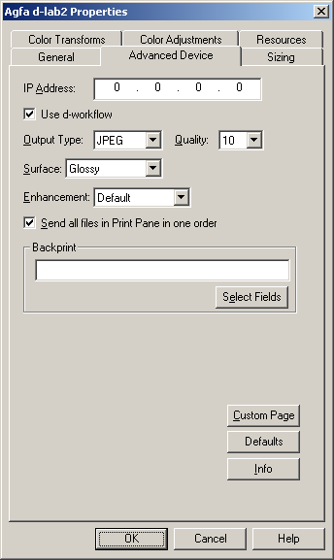
- The driver is now installed.
- After the driver has been installed additional device properties can be set. Select Edit Default Queue Properties Advanced Device.
- Enter the IP Address of the Agfa d-Workflow PC.
- Select Use d-workflow. This requires Agfa release 7.50P or greater. All previous releases should uncheck this box.
- Select the Output Type and Quality.
Note: TIFF is only available for the dlab.3.
- Select the Surface.
Note: Matte is only available for the MSC.
- Select or deselect Send all Files in Print Pane as one order.
- Define the Backprint information.
- Click OK

Making a Custom Page Size

RasterPlus comes with a selection of page or paper sizes but you may wish to create a custom page size for a special application or assign an existing page size to a paper defined for the current device.

To make a custom page size:
- Select Edit Default Queue Properties Advanced Device.
- Click the Custom Page button, which opens the following dialog box. This dialog box displays the current page sizes and the associated definition.

To modify an existing page:
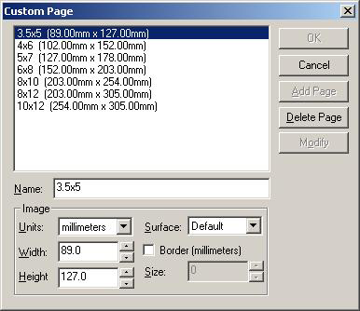
- Select the page to be modified. Change the image information as desired.
- Click on the Modify button.

To add a new page:
- Enter a new name in the Name field.
- Enter the desired Image information.
- Units - Specifies how Width/Height will be defined
- Width - Specifies the Media Width
- Height - Specifies the Media Height
- Surface - Surface type to be used for this media
  - Default - Default to the surface defined in RasterPlus Advanced device
  - Undefined - Special 'Other' surface
  - Any - Use whatever is on the printer
- Border - Define the border size to create a 'Bordered Print'
Note: Border must be checked AND a size greater than zero specified for this option to work.
- Click on the Add button.
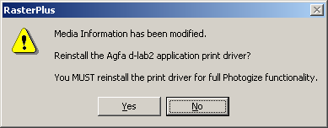
- Click the OK button.
- Click the OK button on the Advanced Devices dialog.
- A message box is displayed. Click Yes.
This will update the media based on the changes made in the Advanced Device dialog box. This will display the Select Published Papers dialog. Select or deselect the media sizes that will be available when File Printing.
- The driver is now ready to print.

Fuji Frontier
RasterPlus supports the Frontier 330, Frontier 350, Frontier 370, and Frontier 390 with this driver.

Installation
- Open RasterPlus. Create a queue for the appropriate device.
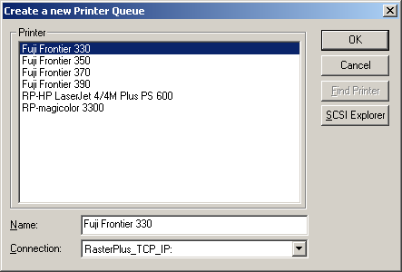

- Select the paper sizes that should be available to the print driver.
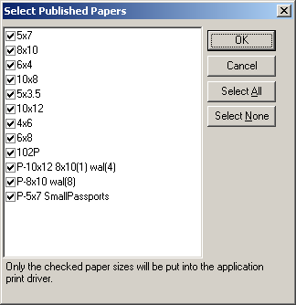
NOTE: The Name defined in RasterPlus MUST be exactly the same as the paper sizes defined in the Frontier Print Size setup. These paper sizes ARE case sensitive.

- Select Edit...Default Queue Properties...Advanced Device.
- Select the appropriate Interface.
  - US Standard
  - PIC Pro
  - C4/C5

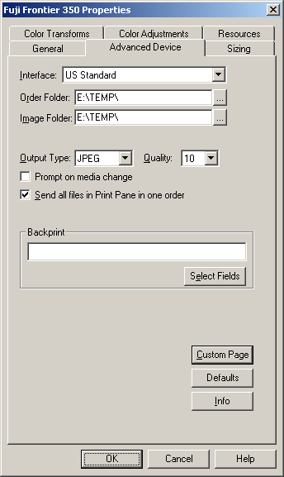
US Standard Interface

- Click the button to the right of the Order Folder: path field. This opens a dialog box called Select Directory.
NOTE: Version 2.0 or greater should point to the "PrintRequest" folder.
Versions prior to 2.0 MUST point to the "DIManager\RemoteOrder" directory.

- Click the button to the right of the Image Folder: path field. This opens a dialog box called Select Directory. The images can be placed anywhere as long as the location is a valid UNC path accessible by the Frontier PC.
- Select or deselect the `Prompt on media change' When `Prompt on media change' is selected RasterPlus will pause processing and prompt the operator to verify the Frontier media.
- Select the Output Type and Quality.
- Select or deselect Send all files in Print Pane as one order.
- Define the Backprint text.
- Click OK.
- The driver is now ready to print.

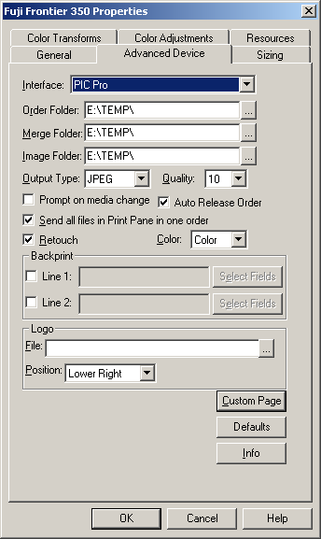
PIC Pro Interface

- Click the button to the right of the Order Folder: path field. This opens a dialog box called Select Directory. This folder must be the Order Data folder on the PicPro Labserver.
- Click the button to the right of the Merge Folder: path field. This opens a dialog box called Select Directory. This folder must be the Merge Data folder on the PicPro Labserver.
- Click the button to the right of the Image Folder: path field. This opens a dialog box called Select Directory. This folder must be the DIGIN folder on the PicPro Labserver.
- Select the Output Type and Quality.
- Select or deselect the “Prompt on media change”. When “Prompt on media change” is selected RasterPlus will pause processing and prompt the operator to verify the Frontier media.
- Select or deselect “Auto Release Order”. If “Auto Release Order” is not selected an operator will have to manually release the order on the PicPro.
- Select or deselect Send all files in Print Pane as one order.
- Select or deselect Retouch
- Select the appropriate Color option
- Define the Backprint text.
- Specify the Logo File. . .if required.
- Select the position of the Logo File
- Click OK.
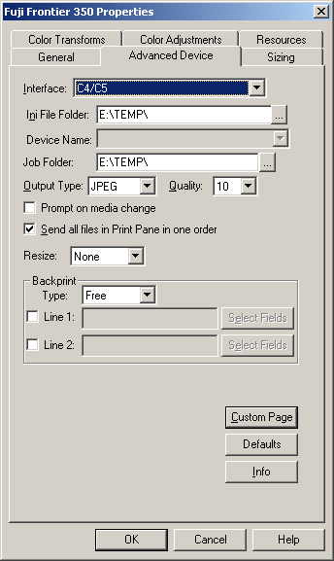
- The driver is now ready to print.

C4/C5 Interface
- Specify the folder the contains the FdiaDevice.ini file. The device names will be extracted from this file and placed in the Device Name field.
- Select the device in the Device Name field.
- Click the button to the right of the Job Folder.
  - This opens a dialog box called Select Directory.
  - This folder should be the Frontier Job Folder.
- Select the Output Type and Quality.
- Select Resize option
- Select or deselect the `Prompt on media change'. When `Prompt on media change' is selected RasterPlus will pause processing and prompt the operator to verify the Frontier media.
- Select or deselect Send all files in Print Pane as one order.
- Select the backprint Type.
- Define the Backprint text.
- Click OK.
- The driver is now ready to print.

Making a Custom Page Size
RasterPlus comes with a selection of page or paper sizes but you may wish to create a custom page size for a special application or assign an existing page size to a paper defined for the current device.

To make a custom page size:
- Select Edit...Default Queue Properties...Advanced Device.
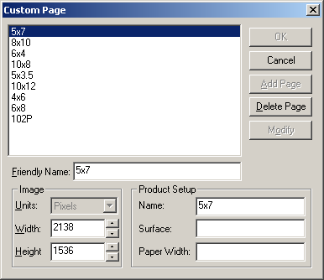
- Click the Custom Page button, which opens the following dialog box. This dialog box displays the current page sizes and the associated definition.

Note: Pixels is the only valid definition for an image size. This information is used by the Frontier to determine a valid image size and MUST match exactly the definition of the Frontier Print Size setup.

The `Friendly Name' is the identifier that will be seen by the operator.

Product Setup Information
The Name defined in the Product Setup MUST be exactly the same as the paper sizes defined in the Frontier Print Size setup. These paper sizes ARE case sensitive.

The Surface and Paper Width are used when `Prompt to change media' is check. These fields will be used in the dialog box to notify the operator which paper should be loaded on the Frontier for the job that is about to print.

To modify an existing page:
- Select the page to be modified. Change the Image information as desired.
- Click on the Modify button.

To add a new page:
- Enter a new name in the Name field.
- Define the Image information to be used for this page.
- Click on the Add button.
- Click the OK button.
- Click the OK button on the Advance Devices dialog.
- A message box is displayed. Click Yes. This will update the media based on the changes made in the Advanced Device dialog box. This will display the Select Published Papers dialog. Select or deselect the media sizes that will be available when File Printing.
- The driver is now ready to print.

Generic Minilab

Installation
- Open RasterPlus. Create a queue for the appropriate device.
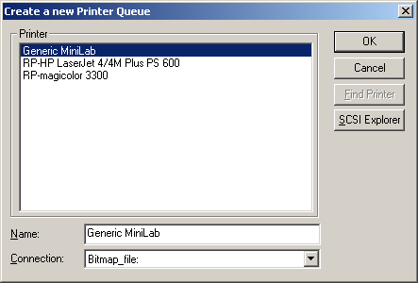

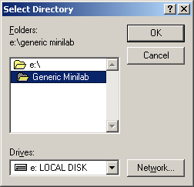
- Select Edit...Default Queue Properties...Advanced Device. Click the button to the right of the Destination: path field. This opens a dialog box called Select Directory.

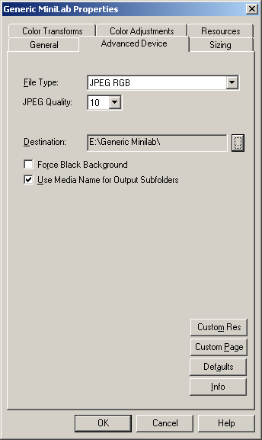
- Select the Output Type and Quality.
- Select or deselect Force Black Background.
- Select or deselect Use Media name for Output Subfolders.
- Click OK.
- The driver is now ready to print.

Making a Custom Page Size
RasterPlus comes with a selection of page or paper sizes but you may wish to create a custom page size for a special application or assign an existing page size to a paper defined for the current device.

- To make a custom page size, select Edit...Default Queue Properties...Advanced Device.
- Click the Custom Page button, which opens the following dialog box. This dialog box displays the current page sizes and the associated definition.
- Modify an existing page.
  - Select the page to be modified. Change the Image information as desired.
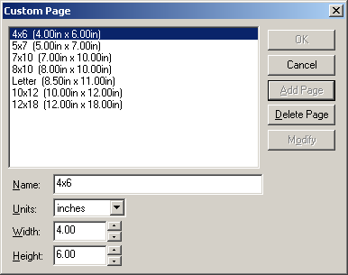
  - Click on the Modify button.
- Add a new page.
  - Enter a new name in the Name field.
  - Define the Image and Paper to be used for this page.
  - Click on the Add Button.
- Click OK.
- Click OK on the Advance Devices dialog.
- A message box is displayed. Click Yes. This will update the media based on the changes made in the Advanced Device dialog box. This will display the Select Published Papers dialog. Select or deselect the media sizes that will be available when File Printing.
- The driver is now ready to print.

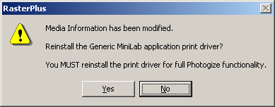

Making a Custom Resolution
RasterPlus comes with a selection of resolution but you may wish to create a different resolution for a special application.

- To make a custom page size, select Edit...Default Queue Properties...Advanced Device.
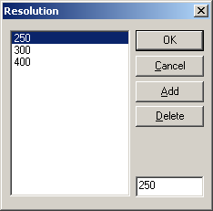
- Click the Custom Resolution button, which opens the following dialog box. This dialog box displays the current resolution.
- Enter the resolution that is to be added.
- Click the Add button.
- Click OK.
- Click the OK button on the Advance Devices dialog.
- A message box is displayed. Click Yes. This will update the media based on the changes made in the Advanced Device dialog box. This will display the Select Published Papers dialog. Select or deselect the media sizes that will be available when File Printing.
- The driver is now ready to print to use the new resolution.

Gretag NETPRINTER and MILECA
RasterPlus supports the Gretag Netprinter 812, Netprinter Digital Station and printers via a network connection for file transfer.

Installation
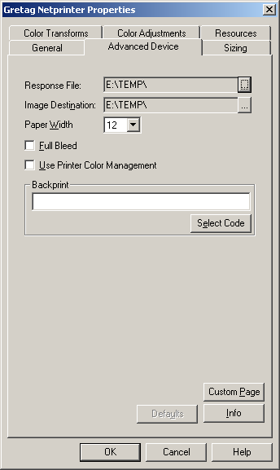
Consult the CREW manual before installing RasterPlus.

- Before opening RasterPlus, select the directory on the network that is defined in the CREW client that will accept the "Response File" and map this to a drive.
- Map another drive to folder to the CREW Hotfolder that is being monitored by the Netprinter. This hotfolder must be accessible to both RasterPlus and CREW. See the CREW manual or your Gretag installer.
- Open RasterPlus. Select Edit...Default Queue Properties...Advanced Device.

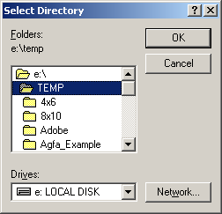
- Click the button to the right of the Response File path field. This opens a dialog box called Select Directory. Select the mapped drive you set up in Step 1, then click OK. Likewise, the Image Destination must point to the drive you mapped in Step 2.
- Select or deselect Full Bleed.
- Select or deselect Printer Color Management. If you select this option do not use ICC profiles, which are selected under the Color Transforms tab. You may be applying color correction twice.

Making a Custom Page Size
RasterPlus comes with a large selection of standard page or paper sizes but you may wish to create custom page size for a special application.

- To make a custom page size, select Edit...Default Queue Properties...Advanced Device.
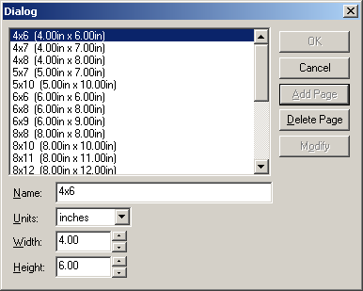
- Click the Custom Page button that opens a dialog box where you will also see the available page sizes. Enter a name for the new custom page that includes the desired dimensions. Enter the width and height. Click the Add Page button. You can also delete page sizes or modify existing ones here. The new page size will now be available in Edit...Default Queue Properties...General...Media Size.

Custom Packages and Overlays
RasterPlus comes with a variety of standard photo package configurations that are selectable in Edit...Default Queue Properties...General...Media Size. When customers require non-standard image sizes within a Package, or you wish to create custom graphical overlays for packages, use PackagePlus; an optional Graphx program that integrates with the Gretag Netprinter/ Mileca version of RasterPlus. For more information, refer to the chapter on Digital Package Printing.

Setting Resolution
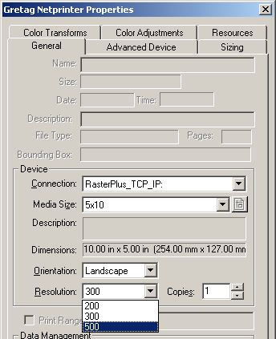
To change the output resolution you must change the setting on the Netprinter and in RasterPlus. Select Edit... Default Queue Properties...General. In the Resolution pulldown select the resolution that matches the setting on the Netprinter.

Kodak DLS Minilab
RasterPlus Plus supports the Kodak 2711 DLS, Kodak 2721 DLS, Gretag digital DLS, Phogenix DFX, System 88 DLS, System 89 DLS, and Noritsu 2921 DLS, Noritsu 3011 DLS devices.

RasterPlus supports the above drivers with the following systems requirements:

- The System Management Software for Kodak DLS Minilab should be Version 1.1A with Mod 2.

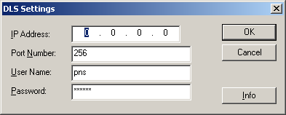
Connection to the DLS
RasterPlus communicates with the Kodak DLS Minilab host computer via TCP/IP. Contact your IT manager or Kodak/Noritsu installer for the Network settings for IP Address, Port Number, User Name, and Password.

Connect the RasterPlus host computer into the same network as the Kodak DLS. (10/100baseT TCP/IP network). These settings may also be applied in Queue Properties...Advanced Device.
Output Type may also be selected.

This dialog box is presented by RasterPlus upon initial installation, or reinstallation of the Kodak DLS driver.

Output type - image quality setting
In Kodak DLS Minilab Properties...Advanced Device, the default setting is JPEG, Quality 6, similar to file type settings in Adobe Photoshop. Quality 6 creates a file with a medium level of compression and almost no noticeable loss in image quality. Likewise a setting of Quality 10 provides almost no compression, while Quality 1 makes the smallest file but sacrifices image quality. Experienced operators who seek to maximize file transfer speeds for optimal performance should adjust these settings. The other output file type is TIFF, which makes a loss less file without compression and provides the highest quality image.

Options for Customer Order Files
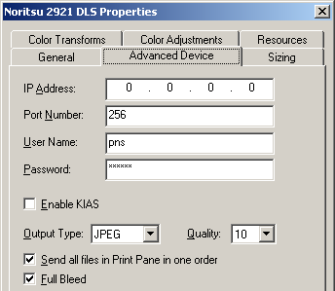
The checkbox Send all files in Print Pane in one order addresses how COS files (Customer Order files) are sent to the printer. When checked, all files in the RasterPlus Print pane will be sent as one order. Up to 40 files may be sent simultaneously. Files beyond the quantity 40 cutoff will be compiled in the next order that processes immediately after. When unchecked, files are sent as individual orders.

Full Bleed
An image that bleeds beyond the page boundaries enables an automatic print or paper cutter to produce a print with an image that comes precisely to the paper edge. The following parameters are applied when Full Bleed is checked:
- If the print is < 6 inches, the bleed = 1 millimeter.
- If the print is > 6 inches and < 2 inches, the bleed = 1.5 millimeter.
- If the print is > 12 inches, the bleed = 2.0 millimeter.
Package Printing from a Macintosh
Package printing options are available to Windows and Macintosh clients on a network when the Kodak DLS printer driver is set up as a shared network resource. On Windows, a comprehensive range of paper sizes and packages is available. However, limitations of the Macintosh OS restrict the availability of all the packages. Only one package for each standard paper size can be seen from a Mac.

Making a Custom Page Size
RasterPlus comes with a large selection of standard page or paper sizes but you may wish to create custom page size for a special application.

- To make a custom page size, select Edit...Default Queue Properties...Advanced Device.
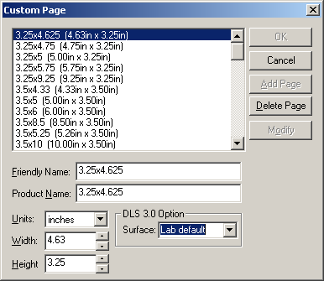
- Click the Custom Page button that opens a dialog box where you will also see the available page sizes. Enter a name for the new custom page that includes the desired dimensions. Enter the width and height. Click the Add Page button. You can also delete page sizes or modify existing ones here. The new page size will now be available in Edit...Default Queue Properties...General...Media Size.

Special Notes:
- The ‘Product Name’ must match a product defined in the DLS. If this ‘Product Name’ dose not match a DLS product the image will NOT print.
- The surfaces define here are mapped to the DLS Paper Surface as follows:
  - Paper Surface 1:
    - Lab Default,
    - Glossy
    - High Glossy.
  - Paper Surface 2:
    - Smooth Lustre
    - Ultra Smooth Hi Lustre
    - Fine Grained Lustre
    - Lustre.
  - Paper Surface 3:
    - Semi Matte
  - Paper Surface 4:
    - Matte
    - Deep Matte.
  - Paper Surface Set to DLS Default Value
    - Other
    - Silk
    - Laminate

Konica
RasterPlus supports the QD-21, QD-21 Plus, R1 devices with this driver.

Installation
- Open RasterPlus. Create a queue for the appropriate device.
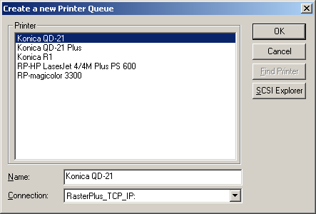
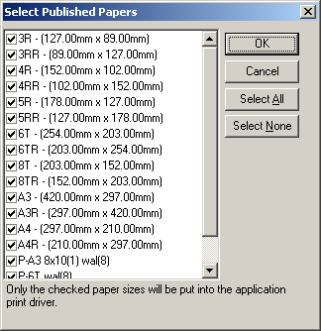
- Select the paper sizes that should be available to the print driver.

- Select Edit...Default Queue Properties...Advanced Device.
Click the button to the right of the Data Folder: path field. This opens a dialog box called Select Directory. This field MUST point to the `QDPRINT' directory. See the printer installation manual or contact your Konica installer for detailed information.
- Select the Output Type and Quality.
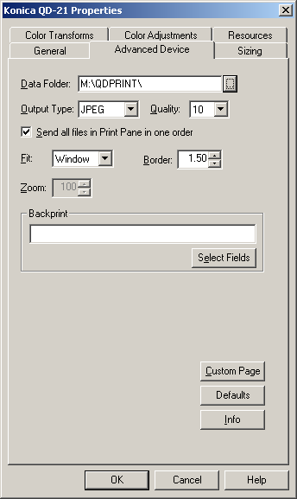
- Select or deselect Send all files in Print Pane as one order.
- Select the Fit, Border, and Zoom options.
- Define the Backprint text.
- Click OK.
- The driver is now ready to print.

Making a Custom Page Size
RasterPlus comes with a selection of page or paper sizes but you may wish to create a custom page size for a special application or assign an existing page size to a paper defined for the current device.

To make a custom page size:
- Select Edit...Default Queue Properties...Advanced Device.
- Click the Custom Page button, which opens the following dialog box. This dialog box displays the current page sizes and the associated definition.

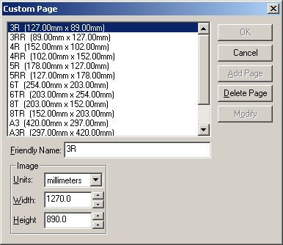

To modify an existing page:
- Select the page to be modified. Change the Image information as desired.
- Click on the Modify button.

To add a new page:
- Enter a new name in the Name field.
- Define the Image to be used for this page.
- Click on the Add button.
- Click the OK button.
- Click the OK button on the Advance Devices dialog.
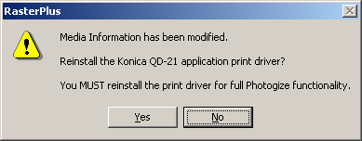
- A message box is displayed. Click Yes. This will update the media based on the changes made in the Advanced Device dialog box. This will display the Select Published Papers dialog. Select or deselect the media sizes that will be available when File Printing.
- The driver is now ready to print.

Noritsu
RasterPlus supports the MP-1600, QSS-2701, QSS-2801, QSS-2802, QSS-2901, QSS-3001, QSS-3011, QSS-3101, QSS-31PRO, QSS 32 Series, QSS-33 Series and dDP Series Noritsu devices.

MP-1600 AND QSS-2701
RasterPlus supports the above devices with the following requirements:

- EZ-Mall must be installed on the MP-1600 or QSS-2701 printer.
- RasterPlus must have access to the printer's PC through the network.

Installation
- Create the network directory that will be used for the EZ-Mall Hotfolder interface.
- Set up the EZ-Mall Hotfolder interface.
- Create a mapped network drive pointing to the directory created in Step 1.
- Create a mapped network drive pointing to the ProgramFiles directory on the device PC. This will be used in a later step.
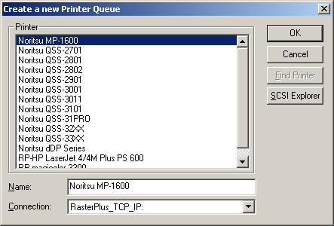
- Open RasterPlus. Create a queue for the appropriate device.
- Select the paper sizes that should be available to the print driver.
NOTE: This is best done after step 9. The initial values are default values that have not yet been associated with channels.
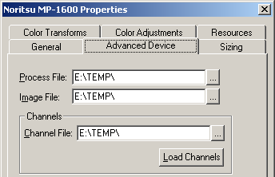
- Select Edit...Default Queue Properties...Advanced Device. Click the button to the right of the Process File: path field. The opens a dialog box called Select Directory. Select the mapped drive created in step 3, and then click OK. Likewise the Image File must point to the drive that you mapped in step 3.
- Click the button to the right of the Channel File: path field. The opens a dialog box called Select Directory. Select the location that contains the Channel Information File on your Minilab System. This should be located in the folder Program Files\NKC\Data.
- Click Load Channels button. This will display a message box that indicates the number of channels found in the channel file. If load channels fails an error message box will be displayed. Correct the error and retry. Select the Output Type and Quality.
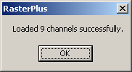

- Select or deselect Send all files in Print Pane as one order
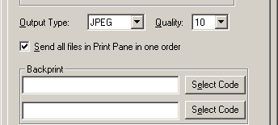
- Define the Backprint text.
- Click OK.

- A message box is displayed. Click Yes. This will update the media based on the changes made in the Advanced Device dialog box. This will display the Select Published Papers dialog. Select or deselect the media sizes that will be available when File Printing.

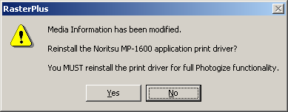
- The driver is now ready to print.

QSS-2801, QSS-2802, QSS-2901,QSS-3001, QSS-3011, QSS-3101, QSS-31PRO, QSS-32 Series, QSS-33 Series, dDP Series

RasterPlus supports the above devices with the following requirements:

- Net Order software must be installed on the device.

Connection to QSS Minilabs
RasterPlus communicates with the Net Order software via TCP/IP. Contact your IT manager of Noritsu installer for the network settings for IP Address.

Connect the RasterPlus host computer into the same network as the Net Order PC.
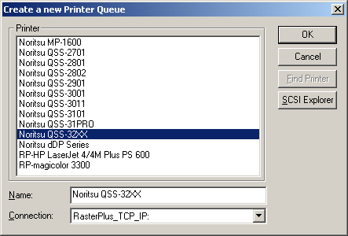

Installation
- Open RasterPlus. Create a queue for the appropriate device.
- Select the paper sizes that should be available to the print driver.
NOTE: This is best done after creating the Custom Page sizes after the machine Paper Width and Advance are assigned.
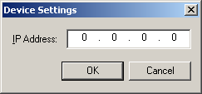
- Enter the TCP/IP address provide by your IT Manager or Noritsu installer.
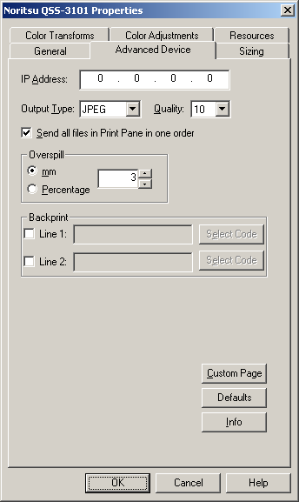
- Select Edit...Default Queue Properties...Advanced Device.
- Select the Output Type and Quality.
- Select or deselect Send all files in Print Pane as one order.
- Select Overspill type and value as required.
- Define the Backprint text.
- Click OK.
- The driver is now ready to print.

Making a Custom Page Size
RasterPlus comes with a selection of page or paper sizes but you may wish to create a custom page size for a special application or assign an existing page size to a paper defined for the current device.

- To make a custom page size, select Edit...Default Queue Properties...Advanced Device.
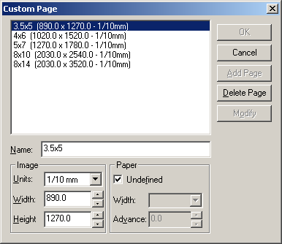
- Click the Custom Page button, which opens the following dialog box. This dialog box displays the current page sizes and the associated definition.
- Modify an existing page.
  - Select the page to be modified. Change the Image or Paper information as desired.
    - Selecting Undefined paper causes RasterPlus to search for a registered paper size, at print time, that will allow the image to print.
    - A defined paper size, Width and Advance, causes RasterPlus to print the image to the specified Paper.
  - Click on the Modify button.

- Add a new page.
  - Enter a new name in the Name field.
  - Define the Image and Paper to be used for this page.
  - Click on the Add Button.
- Click the OK button.
- Click the OK button on the Advance Devices dialog.
- A message box is displayed. Click Yes. This will update the media based on the changes made in the Advanced Device dialog box. This will display the Select Published Papers dialog. Select or deselect the media sizes that will be available when File Printing.
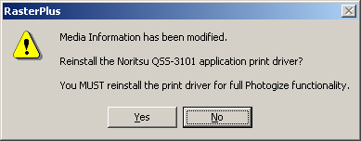
- The driver is now ready to print.

Film Recorders

AGFA/Matrix Color Film Rrecorders
RasterPlus supports most Agfa film recorders via GPIB or SCSI interface.

Model | 95-GPIB | 95- SCSI | NT-GPIB | NT-SCSI
Matrix QCR-D/Z | Yes | No | Yes | No
Matrix PCR | Yes | No | Yes | No
Agfa PCR II/Plus | Yes | Yes | Yes | Yes
Agfa ProColor | Yes | Yes | Yes | Yes
Agfa Alto | Yes | Yes | Yes | Yes
Agfa Forte | Yes | Yes | Yes | Yes
Agfa FotoColor | Yes | Yes | Yes | Yes
Agfa FotoPro | Yes | Yes | Yes | Yes

SCSI Printing
To properly install an Agfa/Matrix Color Film Recorder as a SCSI Device under Windows, refer to the Connecting Your Device chapter in this manual.

GPIB Printing
To properly install an Agfa/Matrix Color Film Recorder using GPIB under Windows, refer to the Connecting Your Device chapter in this manual.

Agfa PPD Files
RasterPlus has PostScript Printer Description (PPD) files that describe the features of all the supported printers. These PPD files may be needed by some applications like PageMaker and when configuring to print from a network node. The PPD files are created when the printer is installed under Windows and placed in the RasterPlus\CrossPlatform directory.

pcr.ppd Agfa PCR
pcrii.ppd Agfa PCR II/PCR II Plus
qcr.ppd Agfa QCR
forte.ppd Agfa Forte
procolor.ppd Agfa ProColor
alto.ppd Agfa Alto
fotocolor.ppd Agfa Fotocolor
proslide.ppd Agfa ProSlide

CCG Color Film Recorders
RasterPlus supports most CCG film recorders via GPIB or SCSI interface.

Model | 95-GPIB | 95-SCSI | NT-GPIB | NT-SCSI
CCG PCR P | Yes | Yes | Yes | Yes
CCG PCR 4 | Yes | Yes | Yes | Yes
CCG PCR 8 | Yes | Yes | Yes | Yes
CCG PCR 16 | Yes | Yes | Yes | Yes

SCSI Printing
To properly install a CCG Color Film Recorder as a SCSI Device under Windows, refer to the Connecting Your Device chapter in this manual.

GPIB Printing
To properly install a CCG Color Film Recorder using GPIB under Windows, refer to the Connecting Your Device chapter in this manual.

CCG PPD Files
RasterPlus has PostScript Printer Description (PPD) files that describe the features of all the supported printers. These PPD files may be needed by some applications like PageMaker and when configuring to print from a network node. The PPD files are created when the printer is installed under Windows and placed in the RasterPlus\CrossPlatform directory.

CCG PCR P | Pcrp.ppd
CCG PCR 4 | Pcr4.ppd
CCG PCR 8 | Pcr8.ppd
CCG PCR 16 | Pcr16.ppd

LaserGraphics
RasterPlus supports the following Lasergraphics film recorders in Windows 95/98 and Windows NT 4.0 via SCSI:

Personal LFR Plus
Personal LFR
Personal LFR X
Personal LFR X-95
Personal LFR PRO
Mark II
Mark II DPM
Mark III
Mark III DPM
Mark V DPM
Mark VI DPM

SCSI Printing
To properly install the Lasergraphics film recorder as a SCSI Device under Windows, refer to the SCSI Devices chapter in this manual.

Film Tuning
To create new films using a base film and the color adjustments:

- Select your base film in the Options dialog.
- Adjust the colors.
- Click Save Film.
- Name the film.

The new film will be created and selected in the Combo box. The red, green and blue color adjustments will reset as if this were a new base film. Any further color adjustments will multiply the originals. For example, if you create Elite II NEW with Elite II as the base with red = 120, it will show up with red = 100. If you select red = 110 with Elite II NEW, it will actually be Elite II with red = (120 * 110 / 100). The values are naturally clamped to 25 and 400.

You can also delete a new film by selecting the film in the Combo box and clicking "Delete Film". Base films cannot be deleted.

Important Note on Film Tuning!
The print drivers installed by RasterPlus in Windows will include these new films if they exist at the time of print driver installation. If you add or delete custom films, you should remove the print driver from the Windows printer control panel and re-install it so the new film tables will appear.

Lasergraphics PPD Files
RasterPlus has PostScript Printer Description (PPD) files that describe the features of all the supported printers. These PPD files may be needed by some applications like PageMaker and when configuring to print from a network node. The PPD files are created when the printer is installed under Windows and placed in the RasterPlus\CrossPlatform directory.

persplus.ppd Personal LFR Plus
perslfr.ppd Personal LFR
lfrx.ppd Personal LFR X
lfrx95.pps PersonalLFR X-95
mark2.ppd Mark II
mark2dpm.ppd Mark II DPM
mark3.ppd Mark III
mark3dpm. Mark III DPM
mark5dpm.ppd Mark V DPM
mark6dpm.ppd Mark VI DPM

MGI
RasterPlus supports most MGI film recorders via GPIB or SCSI interface.

Model | 95-GPIB | 95-SCSI | NT-GPIB | NT-SCSI
MGI Solitaire 4/8/16 | Yes | No | Yes | No
MGI Solitaire 16xps | Yes | Yes | Yes | Yes
MGI Gemini | Yes | Yes | Yes | Yes
MGI Cine II/III | Yes | Yes | Yes | Yes
MGI Sapphire | Yes | No | Yes | No
MGI Sapphire Pro | Yes | Yes | Yes | Yes
MGI Opal | Yes | Yes | Yes | Yes
MGI Opal Plus | Yes | Yes | Yes | Yes
MGI Solitaire 8xp | Yes | Yes | Yes | Yes

SCSI Printing
To properly install an MGI Color Film Recorder as a SCSI Device under Windows, refer to the Connecting Your Device chapter in this manual.

This version of RasterPlus supports most MGI cameras via a SCSI interface board. Because of limitations inherent in the Windows SCSI system, the following film recorders are NOT supported via SCSI: MGI Sapphire, MGI Solitaire 4, 8, and 16.

If you are using SCSI with an MGI film recorder, you must use the Ctrl-A configuration feature of the BIOS SCSI manager during boot-up to set the Initiate Sync Negotiation feature to No and set data transfer rate to it's lowest setting for the SCSI ID which is being used by the film recorder

GPIB Printing
To properly install an MGI Color Film Recorder using GPIB under Windows, refer to the Connecting Your Device chapter in this manual.

MGI PPD Files
RasterPlus has PostScript Printer Description (PPD) files that describe the features of all the supported printers. These PPD files may be needed by some applications like PageMaker and when configuring to print from a network node. The PPD files are created when the printer is installed under Windows and placed in the RasterPlus\CrossPlatform directory.

MGI Opal | opal.ppd
MGI Opal Plus | opalplus.ppd
MGI Solitaire 4 | sol4.ppd
MGI Solitaire 8 | sol8.ppd
MGI Solitaire 16 | sol16.ppd
MGI Solitaire 8xp | sol8xp.ppd
MGI Solitaire 16 xps | sol16xps.ppd
MGI Sapphire | sapphire.ppd
MGI Sapphire Pro | sapppro.ppd
MGI Gemini | gemini.ppd
MGI Cine II/III | cine.ppd

Polaroid Digital Palette
RasterPlus supports the following Polaroid Palette film printers:

Device | Win 95 Interface | WIN NT Interface
CI-3000 | Centronics | Not Supported
CI-3000S | Centronics | Not Supported
CI-5000 S | Centronics and SCSI | SCSI Only
HR 6000 | Centronics and SCSI | SCSI Only
ProPalette 7K Series | Centronics and SCSI | SCSI Only
ProPalette 8K Series | Centronics and SCSI | SCSI Only

LPT Centronics Printing
The LPT port mode should be set to ECP in the BIOS Setup of the computer.

SCSI Printing
To properly install the Polaroid Digital Palette as a SCSI Device under Windows, refer to the SCSI Devices chapter in this manual.

Device Options
When you click Advanced Device from the Queue Properties Job window of RasterPlus, you get the following dialog:

The meaning of these items:

Film Type .............................. Select the type of film you've loaded in the camera; a description of the film will be displayed in the edit box below.

Brightness Calibration .......... Specify what to do when the camera reports a calibration error; only change this on the advice of a Polaroid technician (not available on the ProPalette 8000 and 7000).

Data Delivery ........................ Specify the way that data is sent to the color film recorder; only change this on the advice of a Polaroid technician (not available on the ProPalette 8000 and 7000).

Data Quality ......................... Fast is the default and will result in faster imaging. Fine will result in slower, marginally-higher quality imaging. (not available on the ProPalette 8000 and 7000).

Force black background ....... Fill all non-object areas of the image with black. This is especially useful when imaging 35mm slides where the default white back ground may cause unsightly lines at the edges of the slide.

Single Image Mode...............If checked, will only allow one image in the buffer at a time.
SCSI Adapter # ..................... Defaults to 0. Refers to the physical number of the board the device is connected to. Click Tools...SCSI Explorer for connection information.

Exposure ............................... Set exposure levels on the camera (see below).

Cam Adjust ............................Alter the camera adjust values of the current camera back (see below).

Defaults ................................. Reset all items to their defaults.

Info ........................................ Display a dialog box that displays information about your film printer.

Setting Exposure Levels
When you click the Exposure button in the Options dialog, you get the following dialog: You can move the sliders in the above dialog to change the overall or relative color levels of the images you produce on the Digital Palette.

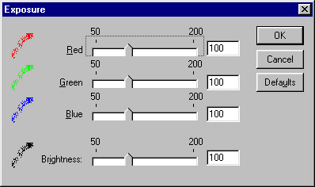

Calibrating your camera
When you click the Cam Adjust button in the Options dialog, you get the following camera adjust dialog:

You use this dialog in the following way to calibrate your camera:

- Add one of the following calibration files to your active queue based on your current camera back.

The files are located in the "Polaroid Calibration" subdirectory of your RasterPlus installation directory.

CA_35MM.CPS for 35mm camera back
CA_AUTO.CPS for Auto camera back
CA_4X5.CPS for 4x5 camera back
CA_PACK.CPS for Pack camera back
CA_6x7.CPS for 6x7 camera back
CA_6x8.CPS for 6x8 camera back

- Click Edit...Default Queue Properties...Advanced Device...Cam Adjust from the main menu of RasterPlus and check the Override for test image box. Keep clicking OK to close all the config dialogs.

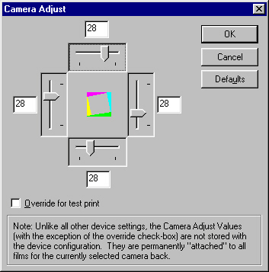

- Print the file to the Palette film printer. A calibration wedge picture will be imaged. Consult your Digital Palette manual for more information on reading the wedge values in the image.

- Click Edit...Default Queue Properties...Advanced Device...Cam Adjust from the main menu of RasterPlus and un-check the Override for test image box. Now enter the wedge values that you got from step 3. Keep clicking OK to close all the config dialogs.

Contact Polaroid technical support for help with this feature.

Polaroid PPD Files
RasterPlus has PostScript Printer Description (PPD) files that describe the features of all the supported printers. These PPD files may be needed by some applications like PageMaker and when configuring to print from a network node. The PPD files are created when the printer is installed under Windows and placed in the RasterPlus\CrossPlatform directory.

ci-3000.ppd Digital Palette CI-3000
ci-3000s.ppd Digital Palette CI-3000s
ci-5000.ppd Digital Palette CI-5000
ci-5000s.ppd Digital Palette CI-5000s
hr6000.ppd Digital Palette HR6000
p7000.ppd Pro7000K Series
p8000.ppd Pro8000K Series

Mirus
RasterPlus supports the Turbo II and Galleria filmprinters from Mirus Industries in Windows 95/98/ME and Windows NT 4.0. In Windows 95, both Centronics and SCSI are supported. In Windows NT 4.0, ONLY SCSI is supported.

SCSI Printing
To properly install the Mirus FilmPrinter as a SCSI Device under Windows, refer to the SCSI Devices chapter in this manual.

Film Tuning
To create new films using a base film and the color adjustments:

- Select your base film in the Advanced Device dialog box.
- Adjust the colors.
- Click Save Film.
- Name the film.

The new film will be created and selected in the combo box. The color adjustments will reset as if this were a new base film. Any further color adjustments will multiply the originals. For example, if you create Elite II NEW with Elite II as the base with Brightness = 120, it will show up with Brightness = 100. If you select Brightness = 110 with Elite II NEW, it will actually be Elite II with Brightness = (120*110/100). The values are naturally clamped to 50 and 200. You can also delete a new film by selecting the film in the Combo box and clicking Delete Film. Base films cannot be deleted.

Important Note on Film Tuning
The print drivers installed by RasterPlus in Global Properties will include these new films if they exist at the time of print driver installation. If you add or delete custom films, you should remove the print driver from Windows using Global Properties and reinstall it so the new film tables will appear.

Mirus PPD Files
RasterPlus has PostScript Printer Description (PPD) files that describe the features of all the supported printers. These PPD files may be needed by some applications like PageMaker and when configuring to print from a network node. The PPD files are created when the printer is installed under Windows and placed in the RasterPlus\CrossPlatform directory.

Turbo II | Turboii.ppd
Galleria | Galleria.ppd
GalleriaPro | Galpro.ppd
GalleriaPro 8 | Galprop.ppd
GalleriaPro E | Galproe.ppd

Montage Graphics
RasterPlus supports the Montage FR2 enhanced in Windows 95 and Windows NT 4.0 via SCSI.

SCSI Installation
To properly install the Montage FR2 film recorder as a SCSI device under Windows, refer to the SCSI Devices chapter in this manual.

Montage PPD Files
RasterPlus has PostScript Printer Description (PPD) files that describe the features of all the supported printers. These PPD files may be needed by some applications like PageMaker and when configuring to print from a network node. The PPD files are created when the printer is installed under Windows and placed in the RasterPlus\CrossPlatform directory.

montage.ppd Montage FR2

Samurai CFR
RasterPlus supports the Samurai CFR In Windows 95 via a Samurai I/O card.

Note that the card must be set to occupy either the memory address range E000 or C900. You should use the System control panel in Windows 95 to determine which resource is available and set the card to this address. RasterPlus will automatically find the card in your system.

Samurai PPD Files
RasterPlus has PostScript Printer Description (PPD) files that describe the features of all the supported printers. These PPD files may be needed by some applications like PageMaker and when configuring to print from a network node. The PPD files are created when the printer is installed under Windows and placed in the RasterPlus\CrossPlatform directory.

samurai.ppd Samurai CFR

Sony UP-D8800/UP-D70A/POLAROID PLD8800
RasterPlus supports the Sony UP-D8800/UP-D70A/Polaroid PLD8800 dye-sub color printer via the Windows ASPI SCSI interface.

SCSI Installation
To properly install these printers as a SCSI device under Windows, refer to the SCSI Devices chapter in this manual.

Digital Package Printing
RasterPlus Windows Edition for the Sony UP-D8800/UP-D70A/Polaroid PLD8800 supports Digital Package Printing. Please refer to the Digital Package Printing section of this manual for more details.

Sony PPD Files
RasterPlus has PostScript Printer Description (PPD) files that describe the features of all the supported printers. These PPD files may be needed by some applications like PageMaker and when configuring to print from a network node. The PPD files are created when the printer is installed under Windows and placed in the RasterPlus\CrossPlatform directory.

up-d70a.ppd UP-D70A printer
up-d8800.ppd Sony UP-D8800 printer
pld8800.ppd Polaroid PLD8800 printer

UTI/Celco
RasterPlus supports most UTI/Celco film recorders via GPIB or SCSI interface.

Model | 95-GPIB | 95-SCSI | NT-GPIB | NT-SCSI
Celco | Yes | No | Yes | No
UTI | Yes | No | Yes | No

GPIB Printing
To properly install an UTI/Celco Color Film Recorder using GPIB under Windows, refer to the Connecting Your Device chapter in this manual.

Celco/UTI PPD Files
RasterPlus has PostScript Printer Description (PPD) files that describe the features of all the supported printers. These PPD files may be needed by some applications like PageMaker and when configuring to print from a network node. The PPD files are created when the printer is installed under Windows and placed in the RasterPlus\CrossPlatform directory.

Celco eXtreme MPR/MPX | Celmpr.ppd
Celco eXtreme Nitro | Celxn.ppd
Celco Professional | Cclpro.ppd
Upgrade Technologies Phoenix | Uti.ppd

Printers

Fuji Pictrography 2000, 3000, 3500, 4000/4000II AND Pictrostat 400
RasterPlus supports the Fuji Pictrography 2000, 3000, 3500, 4000, and Pictrostat Digital 400 via the Windows ASPI SCSI interface.

SCSI Printing
Windows NT 4.0 does not have a built-in ASPI manager like the one included with Windows 95. RasterPlus will automatically run an ASPI installer at the end of its installation. To re-install the ASPI manager, run the ASPIINST.EXE program located in the \ASPI Installer folder of the RasterPlus CD. This applet will install the latest version of ASPI.

Note that RasterPlus supports the Pictrography 4000 and Pictrostat 400 in SCSI-2 mode ONLY. Be sure to set the 4000 and 400 to SCSI-2 (the default) before using it with RasterPlus.

To properly install the Fuji Pictrography as a SCSI Device under Windows, refer to the SCSI Devices chapter in this manual.

Supported Resolutions
The maximum resolution (dpi) that you can set with the Pictrography is based on the amount of memory installed in the printer:
The maximum resolution of the Pictrostat Digital 400 is 400 dpi for all page sizes except A4 Wide, 12x18 and A3 Wide which are 267 dpi.

Installed Memory Maximum Resolution
 | PG 2000,3000 | PG 4000
120MB | - - | 400dpi
48MB | 400dpi | 200dpi
30MB | 320dpi | - -
42MB | 267dpi | - -
6MB | 133dpi | - -

Digital Package Printing
RasterPlus Windows Edition for the Fuji Pictrography 2000, 3000, 3500, 4000 and Pictrostat 400 supports Digital Package Printing. Please refer to the Digital Package Printing section of this manual for more details.

Fuji PPD Files
RasterPlus has PostScript Printer Description (PPD) files that describe the features of all the supported printers. These PPD files may be needed by some applications like PageMaker and when configuring to print from a network node. The PPD files are created when the printer is installed under Windows and placed in the RasterPlus\CrossPlatform directory.

Fuji Pictrography 2000 | Fj2000.ppd
Fuji Pictrography 3000 | Fj3000.ppd
Fuji Pictrography 3500 | Fj3500.ppd
Fuji Pictrography 4000 | Fj4000.ppd
Fuji Pictrography 4000II | Fj4000II.ppd
Fuji Pictrostat 400 | Fj400.ppd

Fuji PrintPix – NC-600D and NC-1000
RasterPlus supports the Fuji NC600D via the Windows ASPI SCSI interface.

SCSI Printing
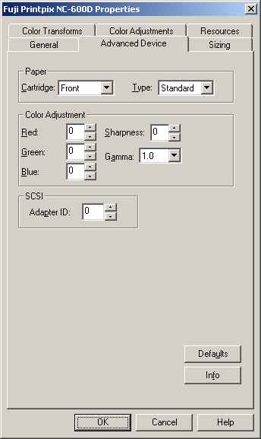
Windows NT 4.0 does not have a built-in ASPI manager like the one included with Windows 95. RasterPlus will automatically run an ASPI installer at the end of its installation. To re-install the ASPI manager, run the ASPIINST.EXE program located in the \ASPI Installer folder of the RasterPlus CD. This applet will install the latest version of ASPI Installation

- Open RasterPlus. Create a queue for the appropriate device.
- Select Edit...Default Queue Properties...Advanced Device.
- Select the Paper Cartridge.
- Select the Paper Type.
NOTE: This selection MUST match the actual cartridge and type in the NC600D or the print will fail.
- Select the Color Adjustments.
- Select the SCSI Adapter, as necessary.
- Click OK.
- The driver is now ready to print.

Kodak XL 7700 AND XLT 7720
RasterPlus supports the Kodak XL 7700 and XLT 7720 dye-sublimation printers via a GPIB interface under Windows 95 or NT 4.0.

GPIB Printing
To properly install a Kodak printer via a GPIB interface refer to the Connecting your Device chapter in this manual.

Before using RasterPlus, make sure that you have a National Instruments 488.2 GPIB board. Some older PC2, PC2A, and AT-GPIB boards are 488.1 and must be upgraded for use in Windows 95 or NT. If you have a DOS GPIB driver with a version starting in C or E, you probably have a 488.1 board; contact National Instruments (1-800-488-IEEE for further assistance).

Kodak PPD Files
RasterPlus has PostScript Printer Description (PPD) files that describe the features of all the supported printers. These PPD files may be needed by some applications like PageMaker and when configuring to print from a network node. The PPD files are created when the printer is installed under Windows and placed in the RasterPlus\CrossPlatform directory.

XL7700 | Xl7700.ppd
XLT7720 | Xlt7720.ppd

Kodak 8650/8670/8660
RasterPlus supports the Kodak 8650/8670 dye-sublimation printers via SCSI

SCSI Printing
To properly install a Kodak as a SCSI device under Windows, refer to the SCSI Devices chapter in this manual.

Kodak PPD Files
RasterPlus has PostScript Printer Description (PPD) files that describe the features of all the supported printers. These PPD files may be needed by some applications like PageMaker and when configuring to print from a network node. The PPD files are created when the printer is installed under Windows and placed in the RasterPlus\CrossPlatform directory.

Kodak 8650 | Kdk8650.ppd
Kodak 8670 | Kdk8670.ppd
Kodak 8660 | Kdk8660.ppd

Mitsubishi 9000D and 9500D Series
RasterPlus supports these Mitsubishi series printers through the USB port.
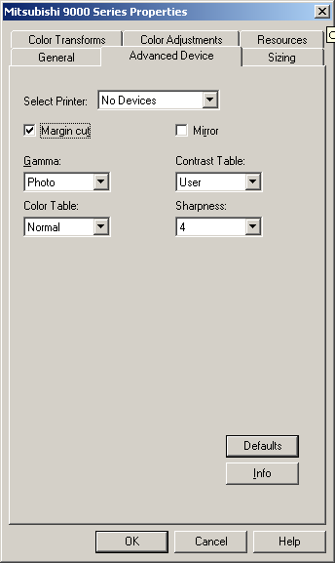
- Select Edit...Default Queue Properties...Advanced Device.
- Select the Printer.
- Check/Uncheck Margin Cut.
- Check/Uncheck Mirror. If checked this will create a ‘mirror image’ of the submitted picture
- Select the Gamma.
- Select the Color Table.
- Select the Contrast Table.
- Select the Sharpness
- Click OK.
- The driver is now ready to print

Sienna/Gretag Fotoprint
RasterPlus will interface with the FotoPrint via a standard Centronics port or FarPoint F/Port enhanced parallel controller card. Since the standard Centronics PC to FotoPrint connection is extremely slow, it is strongly recommended that you acquire and install an F/Port card. For more information on purchasing an F/Port card, please contact Sienna Imaging or FarPoint Communications.

Installing FarPoint F/Port Card Drivers
Follow the installation instructions included with your F/Port card regarding card installation. You should also run the software installer that will put drivers and utilities on your hard disk. You will need to know the interrupt (irq) and base I/O address settings of the card in order to properly run the installer. To make sure that there are no hardware conflicts, you can check the Windows 95 System settings for available irq and I/O settings. To do this:
- Select Start...Settings...Control Panel from the taskbar.
- Double click on System and click the Device Manager tab.
- Double click on Computer and look for available I/O and irq settings.

For more information on installing the FarPoint F/Port card go www.fapo.com.

Sienna PPD Files
RasterPlus has PostScript Printer Description (PPD) files that describe the features of all the supported printers. These PPD files may be needed by some applications like PageMaker and when configuring to print from a network node. The PPD files are created when the printer is installed under Windows and placed in the RasterPlus\CrossPlatform directory.

FotoPrint 500/1000 | Foto1000.ppd
FotoPrint 2000 | Foto2000.ppd
FotoPrint 3000 | Foto3000.ppd
FotoPrint 5000 | Foto5000.ppd

Printer Cloaking with RasterPlus
RasterPlus can print to any Postscript or Non-Postscript printer for which you already have installed a standard Windows Printer Driver. This driver may have come with the printer you purchased, you may have downloaded the driver from the manufacturer, or it may have been automatically installed by the Windows operating system. RasterPlus can in effect take control of, or "cloak" any printer driver such as the Epson Stylus 1270 or 1520 models. This differs from a dedicated RasterPlus driver such as the Fuji 4000II which is automatically installed by RasterPlus

What are the differences between a "True" RasterPlus driver and Printer Cloaking?

- A custom RasterPlus print driver is optimized for a specific device
- Printer Cloaking is best suited to small desktop printers.

Installation
From the menu bar select Printer...New or enter Ctrl+N. In the Window Create a new Printer Queue find the name of the printer you wish to install with the prefix "RP." Several printers may be listed.
Click on that printer name and click OK. You may see a message: Gathering Printer Information. Enter Ctrl+Q or click the Queue Properties button on the menu bar, select the Advanced Properties tab, then the Configure button. You will now have access to controls that are specific to the printer such as paper source, paper quality, and layout functions.

Basic setup is complete. Print to the new driver directly from an application such as Quark or Photoshop, drag and drop files directly into the Hold or Print Queues or a Hotfolder, or Network Print - all the standard RasterPlus functions.

The material in this document is for information only and is subject to change without notice. While reasonable efforts have been made in the preparation of this document to assure its accuracy, Graphx, Inc. assumes no liability resulting from errors or omissions in this document, or from the use of the information contained herein. No part of this manual may be reproduced or transmitted in any form or by any means, electronic or mechanical, including photocopying and recording, for any purpose without the express written permission of Graphx.

Graphx reserves the right to make changes in the product design without reservation and without notification to its users. RasterPlus®, Photogize®, and Graphx® are registered trademarks and MacFilmTM, VisualTransformTM, SmartFitTM and SmartCropTM are trademarks of Graphx, Inc. All other trademarks are the property of their respective owners.

RasterPlus uses the JAWS PostScript Level 3 Interpreter.

© Copyright 2004 Graphx, Inc., all rights reserved.

Graphx, Inc.
400 West Cummings Park
Woburn, MA 01801
Tel. 781.932.0430
Fax. 781.932.0855
www.photogize.com
www.graphx.com

